SpotCancerAI


By:

Muhammad Usman
24761

Hassan Dastagir
40124

Ali Sher Khan
39917

Supervised by: Mr. M Usman Karim
Faculty of Computing
Riphah International University, Islamabad Spring/Fall 2025

A Dissertation Submitted To

Faculty of Computing,
Riphah International University, Islamabad
As a Partial Fulfillment of the Requirement for the Award of the Degree of
Bachelors of Science in Computer Science

Faculty of Computing
Riphah International University, Islamabad

Date: [date of final presentation]

Final Approval

This is to certify that we have read the report submitted by Muhammad Usman(24761), Ali Sher Khan (39917), Hassan Dastagir (40124), for the partial fulfillment of the requirements for the degree of the Bachelors of Science in Computer Science (BSCS). It is our judgment that this report is of sufficient standard to warrant its acceptance by Riphah International University, Islamabad for the degree of Bachelors of Science in Computer Science (BSCS).

Committee:

1 | Mr. M Usman Karim (Supervisor)

2
Dr. Muhammad Musharraf (Head of Department)

Declaration

We hereby declare that this document “[SpotCancerAI]” neither as a whole nor as a part has been copied out from any source. It is further declared that we have done this project with the accompanied report entirely on the basis of our personal efforts, under the proficient guidance of our teachers, especially our supervisor [Mr. M Usman Karim]. If any part of the system is proved to be copied out from any source or found to be reproduction of any project from anywhere else, we shall stand by the consequences.

Muhammad Usman
24761

Hassan Dastagir
40124

Ali Sher Khan
39917

Dedication
Insert dedication Our final year project is dedicated to our parents, friends and teachers, whose love and support have been our pillars of strength. To our professors and especially supervisor " Mr. Usman Karim ", your guidance has shaped our academic journey.

Acknowledgement

First of all we are obliged to Allah Almighty the Merciful, the Beneficent and the source of all Knowledge, for granting us the courage and knowledge to complete this Project.
We extend our heartfelt gratitude to our project supervisor “Mr. Usman Karim”, whose unwavering support, invaluable guidance, and continuous mentorship were indispensable to the successful completion of this project. Their dedication and commitment have been a driving force behind our work.
Furthermore, we want to say a big thank you to our family and friends. They have been our constant source of support and motivation, always encouraging us to do our best and be honest and hardworking.

Muhammad Usman
24761

Hassan Dastagir
40124

Ali Sher Khan
39917

Abstract

The skin cancer and the related dermatological disorders pose an increasing health concern in the worldwide health scenario as early and proper diagnosis is the key to successful treatment. The historical method of handling dermoscopic images involves manual inspection, which is very labor-intensive, subjective, and inefficient when it comes to screening many patients, leading to the implementation of diagnostic systems based on Artificial Intelligence (AI), Machine Learning (ML), and Deep Learning (DL). Nonetheless, there are a number of technical and clinical issues that need to be overcome before these models can be implemented in the actual dermatological practice. SpotCancerAI is a deep learning project that aims to assist with the identification of skin cancer via dermoscopic images with HAM10000 dataset. The proposed project is aimed at developing an application that will preprocess medical images, segment the lesions, and classify them as various types of skin cancers. SpotCancerAI can be used to offer the precise and efficient tool of early diagnosis by integrating image processing methods, such as grayscale conversion, Gausian Blur, and inpainting with the latest machine learning models. The system will be aimed at assisting the dermatologists and making skin cancer screening more accessible, particularly in locations with scarce medical services.

Table of Contents i

Table of Contents

Table of Contents i
List of Tables iii
List of Figures iv
Abstract 5
Introduction 6
    - Opportunities 7
    - Motivation 8
    - Challenges 8
Goals and Objectives 9
    - Goals 9
Scope of the Project 10
1.3.5 Stakeholder Engagement 14
Literature Review Error! Bookmark not defined.
  - Literature Review 16
  - Literature Review Table 20
  - Research Gap 23
Requirements and Design Error! Bookmark not defined.
Implementation and Test Cases Error! Bookmark not defined.
  - Test Case_1 66
    - Test Case_2 68
    - Test Case_3 69
    - Test Case_4 70
    - Test Case_5 72
    - Summary 73
Chapter 5: Experimental Results and Analysis 76
  - Introduction 77
  - Experiments 77
    - EfficientNetB5 Model Performance (OverSample) 77
Classification Report 78
Confusion Metrix 80
    - InceptionV3 Model Performance 80
Classification Report 81
    - ResNet Model Performance 82
Classification Report 83
    - EfficientNetB5 Model Performance (UnderSample) 83
Chapter 6: Conclusion and Future Work 86
  - Conclusion and Future Work. 87
References 88

List of Tables iii

List of Tables
Table 1: Literature Review Table 20
Table 2: Signup 36
Table 3: Login Table 37
Table 4: Create profile 38
Table 5: Upload Image 39
Table 6: Analyze Image 40
Table 7: Add users 41
Table 8:Remove Users 43
Table 9:Check Results 44
Table 10: View User History 45
Table 11: Give Suggestions 46
Table 12:Provide Feedbacks 47
Table 13:FeedBacks 49
Table 14: Dataset Before Balancing 62
Table 15: Dataset After Balancing 63
Table 16: Test Case1 66
Table 17: Test Case 2 68
Table 18:Test Case 3 69
Table 19: Test Case 4 70
Table 20: Test Case 5 72
Table 21: Test Case Metric 74
Table 22:Classification Report 79
Table 23: Classification Report of InceptionNet V3 81
Table 24:Classification Report of ResNet 83
Table 25: Classification Report of EffNet B5 (US) 84

List of Figures iv

List of Figures
Figure 1: Proposed Methodology 29
Figure 2: System Architecture Diagram 30
Figure 3:Skin Cancer Classification 59
Figure 4:Distribution of Classes 60
Figure 5:Balancing of Classes 61
Figure 6:Image Preprocessing 62
Figure 7: CNN Architecture 64
Figure 8: Efficient Net B5 Model Graph 78
Figure 9: Efficient Net B5 Confusion Metrix 80
Figure 10: Inception V3 Model Graph 81
Figure 11: ResNet Model Graph 82
Figure 12: Efficient Net B5 Undersample Model Graph 84

SpotCancerAI 5

Abstract

The skin cancer and other associated dermatological conditions are an increasing international health issue and timely and correct diagnosis is key to successful management. The manual examination of dermoscopic images is tedious, biased, and requires practicality in large-scale screening, which led to the utilization of the Artificial Intelligence (AI), Machine Learning (ML), and Deep Learning (DL)-based diagnostic methods. There are however a few technical and clinical issues that lie ahead before such models can be implanted in the actual dermatology.
SpotCancerAI is a project based on deep learning that is aimed at the detection of skin cancer on skin dermoscopic images on the HAM10000 dataset. The proposed project is devoted to the development of the application that preprocesses medical pictures, identifies lesions, and classifies them into the types of skin cancers. SpotCancerAI is an app that will use a mixture of image processing functions such as grayscale conversion, Gausian Blur and inpainting alongside current machine learning models to deliver an effective and accurate tool in the early detection process. The system should assist dermatologists and make the screening of skin cancer easier, particularly in regions where medical facilities were scarce.

Chapter 1: Introduction

SpotCancerAI 7

Introduction

SpotCancerAI is a creative project which applies machine learning algorithms to identify skin cancer based on the image of a skin lesion. It is aimed to enhance the early diagnosis of the condition and to offer a stable instrument to medical workers. SpotCancerAI investigates the classification and partitioning of the lesions to establish whether they are benign (non- cancerous) or malignant (cancerous) by evaluating a large dataset (HAM10000) of dermatological images. To enhance the quality of the images, the project attaches itself to the sophisticated image processing techniques, such as grayscale conversion, gausian blur, and inpainting, to then use machine learning algorithms. Lastly, SpotCancerAI would be used to help in the early detection of skin cancer, which can save lives by allowing faster and more accurate diseases.

Opportunities

      - Early Detection of Skin Cancer :- SpotCancerAI is able to detect skin cancer earlier, which is necessary in order to enhance survival rates. Timely diagnosis can bring easy and more effective health treatment.
      - Support for Healthcare Professionals :- The system has the capability of being a determination-support system to dermatologists and professionals in the field by alerting them to questionable lesions, minimize human error, and enhance the accuracy of the diagnosis.
      - Improved Access in Underserved Areas :- In the areas where an approach to skin doctors or specialized care is limited, SpotCancerAI might be offered as a component of mobile or telemedicine platforms by which people may obtain initial assessments without the need to travel.
      - Scalability and Speed :- In comparison to conventional diagnostic procedures, machine learning solutions such as SpotCancerAI will be capable of processing images in large quantities in a relatively short period, which is why it is highly scalable to hospitals and clinics with high patient volumes.
      - Educational Tool :- SpotCancerAI can also be used as an educational aid to medical students and trainees that can provide a more practical insight into the way in which the skin wound are defined and categorized with the help of AI.

Cost-Effective Screening

By eliminating the unnecessary biopsies and in-person consultation in the latter case, computer screening using SpotCancerAI has the potential to significantly decrease the costs of medical care by showing that the wound is harmless.

Continuous Improvement with Data

The model can also be constantly refined and re-trained on more varied and current datasets and improved in the long run, particularly in different skin tones and lesion types.

Motivation

The driving force behind the SpotCancerAI project is the grave requirement of early and proper diagnosis of skin cancer especially melanoma which is life threatening should not be diagnosed on time. The conventional diagnostic techniques usually rely on qualified dermatological assessment that may be subjective and also restricted by accessibility, particularly in poorly attended areas. SpotCancerAI is designed to harness the potential of artificial intelligence and computer screening to develop a convenient, dependable and effective skin lesion examination tool. The project aims to assist the medical professional community, minimize the diagnosis errors and eventually enhance patients outcomes by screening the detection process with the help of the sophisticated image processing and deep learning methods, and, consequently, identify potentially cancerous skin lesions much faster and more compatible.

1.1.2 Challenges

The project of SpotCancer AI has certain challenges which may influence the development and success of the project. A significant problem is quality and diversity of data, skin wound data can not be presented in various skin tones, age groups, and the rare forms of cancer, and this can result in biased or less effective models. The other challenge is the intricacy of processing medical images, which are different in appearance depending on light, image quality, and the skin structure because of skin wounds. Wound segmentation is especially challenging whereby because of its high importance, the region of interest needs to be strictly isolated to be classified properly. Additionally, model

SpotCancerAI 9
understandability and clinical validation are essential, as medical professionals need to trust and understand AI-driven decisions before adopting them in practice. Lastly, legal and ethical issues related to patient data privacy and the introduction of AI into healthcare should be addressed cautiously to ensure they use the system in a safe and responsible manner.

Goals and Objectives

Goals
The Objectives of SpotCancerAI will be as follows.:-

      - Detect skin cancer using Machine learning and deep learning models.

      - Classify different types of skin wounds from images.

      - Preprocess images (grayscale, gausian blur, inpainting) for clarity and accuracy.
      - Segment lesion areas to isolate them from background skin.

      - Support early and correct diagnosis for dermatologists.

      - Improve and contribute to Computerized screening or Application in healthcare.

      - Disclose intelligence and tools to the research and developer community.

Objectives

      - Objects The data set to be used in training and testing skin diagnosis detection models are the HAM10000 dataset.
      - To process and sharpen the images with the help of preprocessing techniques such as grayscale change, gausian blur, and inpainting.
      - To correctly separate (segment) the skin wounds from the rest of the image.

      - To train deep learning models that can categorized different types of skin lesions.

      - To estimate the model’s performance using accuracy, precision, recall, and
F1score.

      - To improve the model results by tuning its hyperparameters.

      - To build a complete system that goes from image input to final result.

      - To support early detection of skin cancer and help in use of medical field.

Scope of the Project
The Scope of the Project SpotCancerAI are as following :-

      - AI-Based Skin Cancer Detection: Uses deep learning to classify skin lesions.

      - Fast & Accurate Results: Provides quick analysis to support medical decisions.
      - User-Friendly Interface: Simple and easy-to-use system for both doctors and patients.
      - Data Security & Privacy: Ensures patient information is kept safe.

      - Mobile & Web Compatibility: Can be used on smartphones and computers.

Project Objectives

      - To develop an AI-based system for the early detection of skin wound using dermoscopic images.
      - To apply preprocessing techniques such as grayscale conversion, gausian blur, and inpainting for improving image quality.
      - To perform correct segmentation of skin wounds from background skin to focus on relevant areas.
      - To classify skin wounds into different categories using deep learning models.
      - To estimate the performance of the model using standard metrics like accuracy, precision, recall, and F1-score.
      - To optimize model performance through setting a hyperparameters.

SpotCancerAI 11

      - To create a complete, end-to-end pipeline from image input to final categorical output.
      - To provide a knowledge in medical AI research and support early and efficient disease of skin cancer.

Technological Components

Dataset:

- HAM10000 A large collection of dermoscopic images used for training and training the model.

Programming Language:

- Python Used for data processing, model development, and evaluation.

Libraries and Frameworks:

- NumPy, Pandas For data manipulation and analysis.

- OpenCV For image preprocessing tasks like grayscale conversion, gausian blur, and inpainting.
- Matplotlib, Seaborn For data visualization.

- Scikit-learn For preprocessing, model evaluation, and metrics.

- TensorFlow / Keras or PyTorch For building and training deep learning models.

Image Preprocessing Tools:

- Grayscale conversion

- Gausian blur (for hair and noise removal) III. Inpainting (to restore cleaned image regions)

Deep Learning Models:

- Convolutional Neural Networks (CNNs) Used for image classification and lesion detection.

- (Optional) U-Net or similar architectures – For image segmentation.
- Model Evaluation Metrics:

- Accuracy, Precision, Recall, F1-score – To assess the performance of the classification model.

Development Environment:

- Jupyter Notebook

- Google Colab
- Kaggle Kernels – For interactive development and experimentation.

Hardware:

- GPU (if available) – To accelerate model training and improve performance.

Implementation Phases

Problem Understanding & Dataset Selection
  - Study the problem of skin cancer detection.
  - Select a dataset (HAM10000) for testing and training the model.

Data Preprocessing
  - Load and run the dataset.
  - Apply preprocessing techniques such as: Grayscale conversion
,Gausian Blur , Inpainting

Lesion Segmentation
  - Implement segmentation techniques to extract the wound from the skin image.

Model Development

SpotCancerAI 13

  - Design and train a Convolutional Neural Network (CNN) for wound categorization.

Model Evaluation
  - Test the trained model using estimated metrics such as: Accuracy, Precision, Recall, F-1 Score.
  - Analyze results to identify perfection and imperfection.

Model Optimization
  - Tune hyperparameters to improve model performance.
  - Apply regularization or data augmentation if needed.

Integration & Final Pipeline
  - Combine all steps into one streamlined process.
  - Ensure the pipeline works efficiently from input image to diagnosis.

Documentation & Reporting
  - Document all phases, methods, and results.
  - Prepare reports or presentations to share findings and show the system.

Data Management

The data management plan for the SpotCancerAI project revolves around the HAM10000 dataset, which provides dermoscopic images and associated metadata such as wound types and lesion location. The dataset is maintained in the following folders namely; raw images, processed outputs, segmentation masks, training and testing splits, and metadata.
The preprocessing stage involves the mapping of lesion codes to readable labels, conversion to grayscale, gausian blur and inpainting to eliminate errors such as hair. Images are all standardized (to a single shape e.g. 224x224) to make model input consistent. Stratification is applied to the data in order to maintain class balance by dividing it into training (70%), validation (15%), and testing (15%) sets. Label mapping converts

abbreviated codes such as nv and mel get converted to meaningful classes such as benign and Melanoma.
Data augmentation methods include flipping, rotation, scaling, color, to have model robustness.
jitter, and noise are applied. It is suggested to use versioning tools such as DVC or Github to trace the changes in the data, and backups in clouds or external locations are kept. HAM10000 dataset is publicly available under anonymized conditions, which satisfies more principles as it is anonymized.

Stakeholder Engagement
We had a patient in whom a tiny spot on the skin was ignored as it could not be dangerous, but it was later diagnosed with late skin cancer. Most individuals postpone checkups because of lack of awareness or excessive cost or even access to doctors. The current models of AI are also difficult to work with and unsuitable in darker skin. This prompted us to develop a quick, easy, and convenient AI in detecting skin cancer at an early stage so that people can receive a diagnosis promptly and with high accuracy. The following are some of its Key Features:
      - AI-Based Skin Cancer Detection: Uses deep learning to classify skin lesions.
      - Fast & Accurate Results: Provides quick analysis to support medical decisions.
      - User-Friendly Interface: User-friendly and simple system between the patients and doctors.
      - Data Security & Privacy: Ensures patient information is kept safe.

      - Mobile & Web Compatibility: Can be used on smartphones and computers.

Deliverable

      - System Architecture Documentation: Detailed design documentation of the system architecture, system components and integration points.
      - Training Materials: Development of detailed law enforcement training guides and books.
SpotCancerAI 15

      - Pilot Test Reports: Pilot testing reports, performance reports as well as problems that have been tracked.
      - Deployment Plan: A schedule of complete system implementation, details provided, timelines, resources and duties.
      - Compliance Reports: Record keeping of adherence to legal and other principles, such as privacy impact assessments and bias assessments.

Chapter 2: Literature Review

SpotCancerAI 17

Literature Review

Largely, modern progressions in deep learning have revolutionized the context of early skin cancer diagnosis, especially in the detection of melanoma, the deadliest type of skin cancer. The core of this change is the convolutional neural network (CNN), which has proven to be an impressive performer when it comes to the analysis of dermoscopic and clinical images. By using huge datasets of images like the ISIC 2017, 2018, and the HAM100000, scientists have created highly sophisticated models that are able to compete with human experts in their accuracy.
Among the challenges that are discussed in one of the most outstanding studies [1] is the limited access to healthcare, data imbalance, and diagnosis accuracy using CNNs, few-shot learning, GANs, data augmentation, and transfer learning on the ISIC 2017 and 2018 data. In particular, a CNN model with GAN demonstrated a rather impressive accuracy of 86.1 percent in distinguishing between malignant and benign skin lesions, which demonstrates the high potential of the model to be implemented in telemedicine platforms, particularly in rural and underserved regions, where the resources of the dermatology field are limited.
On the same note, [2] Kalouche used the CNN-based vision models, probably with the VGG-16 architecture on the publicly available ISIC datasets, with classification accuracy equal to expert dermatologists. The classification accuracy of the study was equivalent to that of trained dermatologists due to the strength of CNNs in clinical decision support systems. The authors recommended integrating AI-aided tools in primary healthcare practice to improve outreach of diagnostic and curb health care disparities on dermatologic care. Similarly, [3] deals with the vital issue of early and precise melanoma diagnosis by presenting a hybrid approach to it, which involves deep learning and.

unsupervised clustering. The authors apply a three-stage model to the ISIC-2016 dataset that contains annotated dermoscopic images: firstly, with a skin region refinement model, secondly, the Deep Region-Based Convolutional Neural Network (RCNN) model is utilized to find the lesion, and finally, Fuzzy C-Means (FCM) clustering is used to deal with a precise segmentation. This fusion can be used to detect robust lesions and fine-grained boundaries. The model performed well with a sensitivity of 97.81, specificity of 94.17, Dice coefficient of 0.94 and Jaccard coefficient of 0.93 meaning that it is effective to differentiate between melanoma and benign lesions. The paper identifies the prospects of using CNNs and fuzzy clustering as a means of accurately analyzing skin cancer and proposes the future research directions such as expanding datasets, scaling to real-time clinical use, application to other types of lesions and improved preprocessing methodology in an effort to increase accuracy and scalability in teledermatology.
In response to technical constraints in deep learning, [4] Hasib k al. reconsidered the difficulties of imbalance in the class in medical datasets, and suggested the use of the most advanced sampling methods such as SMOTE and hybrid approaches. Their extensive survey proposes the integration of algorithm- level and data- level approaches to stronger and more justifiable classification models in medical imaging.

Similarly, [5] Ali and Al-Marzouqi investigated CNN-based binary classification to detect melanoma with the help of likely ISIC datasets, which provided encouraging results but proposed that the further research should be conducted in such a way that deep models and ensemble learning can be used to increase their robustness and accuracy. Nasr- Esfahani et al. [6] also made a contribution to this area by automating the process of melanoma detection with CNNs on clinical images, presumably on top of datasets like ISIC or HAM10000. Their model was sensitive and specific without fresh pre-trained networks, and suggesting future applications in mobile teledermatology devices to support early detection in remote areas. The landmark study by Esteva et al. [7] erased the boundary.

SpotCancerAI 19

Inception v3 CNN on more than 129,000 images of various sources, and reaches the level of performance of dermatologists in diagnosing skin cancer. This study formed the basis of the use of AI in the primary care plus telemedicine platforms to enable non-specialist practitioners to be empowered. Mendes and Silvais, [7], on the other hand, subjected standard CNNs on clinical dermoscopy images to the classification of different types of lesions and found their results supporting the validity of CNNs but suggestion of larger and more diverse datasets to enhance the generalization of the models.
Another study by Khan et al. [9], which addresses the issue of the data imbalance, suggested a hybrid sampling approach that involves different sampling strategies oversampling and undersampling with deep learning models. Although they did not use data on skin cancer, their approach has demonstrated better performance in comparison to traditional sampling methods, which implies their broader use in medical settings.
The CNNs introduced by Shoieb et al. [10] to analyze full-field optical coherence tomography (FF- OCT) images to diagnose basal cell carcinoma (BCC) demonstrated high diagnostic sensitivity and sensitivity and recommend its application to larger lesion classes and clinical integration in real-time. A custom CNN on melanoma based on dermoscopic images, which probably were built by Sagar and Dheeba [11], showed promising results. Their future research involves investigation of transfer learning and the use of models together to make the diagnostic abilities even greater.
As a continuation of this work, [12] more recent work has introduced new regularization methods in CNNs to decrease overfitting and enhance generalization, using datasets such as ISIC 2017 and Ham10000, and has a goal to generalize the methods to other architectures and environments. Similar work [13] has been done to automate the classification using deep CNNs with early detection of skin cancer with future directions to include multimodal data and advanced preprocessing to maximize the performance. Additional performance improvements have been obtained by using ensemble structures with models like AlexNet, VGGNet and GoogLeNet by utilizing backpropagationbased fusion models on the ISBI 2017 dataset, with

further effort implied in diversifying the model pool and the dataset.
To add to these developments, [15] a survey of CNN-based dermatology models surveyed CNN-based models, such as ResNet, Inception, and hybrid models with or without SVM and XGBoost, with accuracy rates of 81.59% to 89.9% and a high of 99.33% with an ensemble EfficientNet B7 model. The review highlights the significance of dealing with data imbalance, using various high-quality datasets, and using multimodal clinical data to further enhance the precision of the diagnosis and practical usefulness.

Literature Review Table

Table 1: Literature Review Table

Ref | Dataset (Size &  Source) | ML Technique | Best Metric | Key Strength | Key Weakness
[1] | ISIC 2017,  2018 (~2000+  images) | CNN, GAN,  Transfer Learning | Accuracy: 86.1% | Addresses rural/telemedici n e use, robust  techniques | Moderate accuracy, computational  complexity
[2] | Likely ISIC (~2000  images) | CNN (VGG-16  based) | Accuracy: 91% | Expert-level accuracy | Exact model metrics not  stated
[3] | Hybrid approach | Hybrid approach | Sensitivity: 97.81% | High accuracy in both detection and precise lesion  segmentation | Limited dataset size restricts generalizability

SpotCancerAI 21

[4] | General medical datasets | SMOTE,  Hybrid Sampling | Not Reported | Addresses class imbalance | No specific model  tested
[5] | Likely ISIC | CNN (Binary Classification) | Accuracy: 85% | Simple and  effective approach | Needs  ensemble/deepe r model
[6] | ISIC or HAM10000 | CNN (Custom, not pre-trained) | Accuracy: 92% | Low-resource deployment | Not leveraging pre-trained  networks
[7] | 129,000+  images (Various sources) | CNN (Inception v3) | Accuracy: 91% | Large dataset, real-world  potential | High resource/trainin g cost
[8] | Clinical  dermoscopy photos | Standard CNN | Accuracy: 85% | Supports CNN viability | Needs larger,  more diverse data
[9] | Various (not specific to skin) | Hybrid Sampling + DL | Accuracy: 89% | Improved class balance | Not skin- specific
[10] | FF-OCT BCC  images | Custom CNN | Accuracy: 93% | Adapts to new imaging  types | Limited to BCC, not wide  use yet
[11] | Likely ISIC | Custom CNN | Accuracy: 88% | Potential for  further tuning | Basic  architecture
[12] | ISIC 2017, HAM10000 | CNN + Novel Regularizer | Accuracy: 92% | Improves generalization, reduces  overfitting | No clear metric reported

[13] | ISIC  datasets | Deep CNN | Accuracy: 93% | Automation of detection | Needs multimodal input, no  metrics
[14] | ISBI 2017 (~2000+) | AlexNet  +  VGGNet  +  GoogLeNet Ensemble | Accuracy: 91% | Strong ensemble performance | No exact metric stated
[15] | ISIC, HAM10000  , PH2, etc. | ResNet, Inception, VGG, Hybrid (SVM/XGBoost  ) | Accuracy up to 99.33% | Comprehensive review and comparison | Dependent on dataset quality

Deep learning, and specifically convolutional neural networks, has transformed the primary detection and diagnosis of skin cancer and especially the melanoma cancer type. The research that has used datasets including ISIC 2016, 2017, 2018, and HAM10000 have shown that AI models can reach the performance of expert dermatologists and even surpass it. Such methods as GANs, transfer learning, and ensemble modeling as well as hybrid frameworks that involve fuzzy clustering have advanced further.
increased model strength and accuracy and segmentation accuracy. Although the progress is impressive, there are still such challenges as class imbalance, the lack of diversity of the dataset, and restrictions of real-time deployment. Resolving these problems by employing the sophisticated sampling methods, multimodal integration of data, and mobile optimization will be essential in the translation of AI models in the research setting into scalable and equitable clinical applications. All these developments are promising of more AI-aided teledermatology to come, particularly concerning the expansion of access to care in underserved areas around the globe.

SpotCancerAI 23

Research Gap

    - Integration into Clinical Workflows: There is a vacuum in the seamless application of AI tools to the existing clinical processes, and it is crucial to ensure that the tools are convenient to implement and provide dermatologists with actionable information without disrupting their workflow.
    - Real-time Analysis and Feedback: The models are often found to be deficient in this area, which is required to diagnose and plan treatment in real-time and provide feedback.
    - Lack of Diversity: The dataset contains more of light skin tones and thus is not effective with dark skin.
    - Transparency and Explainability: Particularly deep learning AI models have been charged with being black boxes. Models should offer predictability and transparency in order to be trusted by medical professionals.
    - Resource Constraints in Low-Income Settings: Since the resources and the internet are scarce, the implementation of AI tools in resource-restricted settings is a challenge. To bridge this gap, there is need to develop lightweight models that are able to work well in such situations.

Problem Statement

One of the most common and even lethal cancers all over the world is skin cancer. In order to achieve high survival chances, early and precise diagnosis is an important factor, however, the traditional diagnostic tools tend to be time-consuming, subjective and dependent on specialist knowledge. Dermatologists are scarce, and there are longer delays in diagnosing and receiving expert care due to the increasing cases of skin cancer, particularly in underserved areas. The current automated detection models have challenges related to accuracy and might be ineffective in the case of different skin tones. Hence, the need to develop an AI-based, accessible, and precise skin cancer detection algorithm that would facilitate early cancer diagnostics and enhance health-related outcomes is acute.

Chapter 3: Requirement And Design

SpotCancerAI 25

Introduction:

In this part, we shall define board requirements and design information of us SpotCancerAI System. The goal is to give the correct output and explanation of each of the modules such that the program can be replicated using this document. This will begin with the enumeration of the functional and non-functional requirements, then the hardware and software requirements. We shall then examine the proposed methodology, system architecture, data processing and other pertinent elements to give an overall picture of the system.

Requirements

The requirements of the SpotCancerAI project may be categorized into hardware, software, dataset, functional, and non-functional. The purpose of the project is to apply deep learning models such as CNNs to identify skin cancer, in particular, melanoma.

Functional Requirements :-

Functional needs define the actual behaviour or characteristics of the system. These consist of:

Patients
FR1: The system must ensure that only authorized doctors can access a
patient’s uploaded skin images.
FR2: The system must allow patients to provide or withdraw consent for using their images in model training or research.
FR3: The system must allow patients to request deletion of their personal images and related data.
FR4: The system must ensure that patient identity is anonymized before images are used for training or analysis (if required).

Doctors / Clinicians

FR5: Doctors must be able to upload dermoscopic or clinical images for skin cancer analysis.

FR6: Doctors must be able to view the preprocessed image to verify quality (denoising, enhancement).
FR7: Doctors must receive the system’s diagnosis (melanoma, benign, etc.) along
with a confidence score.
FR8: Doctors must be able to view segmentation masks and heatmaps that explain the prediction.
FR9: Doctors must be able to manually adjust segmentation if the system-generated mask is inaccurate.
FR10: Doctors must be able to download or print diagnostic reports for patient consultation or record keeping.
FR11: Physicians should have the capacity to control and peruse previous cases of patients, and their prior forecasts.

Administrators (System Admins)
FR12: Admins should have the capability to add, delete and control user accounts (patients, doctors).
FR13: The admins should be capable of assigning and managing access permissions regarding all the user roles.
FR14: Admins should have the ability to check and see the logs of activity in the system (uploads, predictions, edits).
FR15: Admins should have a possibility to implement such security policies as password regulations, two-factor authentication, and encryption.
FR16: Admins must be able to manage system maintenance tasks including backups, updates, and uptime monitoring.
FR17: Admins must be able to configure and review data retention, deletion, and privacy compliance policies.

Non – Functional Requirements:-

- Accuracy: The model should achieve high accuracy, sensitivity, and specificity, especially for malignant cases.

SpotCancerAI 27

- Scalability: The system should handle large volumes of image data efficiently.
- Usability: The UI should be clean and accessible to both medical professionals and researchers.
- Security: All uploaded data must be securely stored and compliant with data privacy regulations (e.g., HIPAA or GDPR if applicable).
- Performance: The system should deliver real-time or near-real-time predictions.

Software and Hardware Requirements:-

Software Requirements Development Environment :-
  - Operating System: Windows 10/11, Ubuntu 20.04+, or macOS 12+
  - Programming Language: Python 3.8+
  - IDE/Editor: VS Code, Jupyter Notebook, or PyCharm

Libraries and Frameworks:
    - Data Handling: NumPy, Pandas
    - Image Processing: OpenCV, PIL
    - Visualization: Matplotlib, Seaborn
    - Machine Learning / Deep Learning: TensorFlow or PyTorch, Scikit- learn, Keras
    - Web Interface (if applicable): Flask, Streamlit, or FastAPI

Deployment Environment

- Web Server: Nginx or Apache (optional, for production deployment)
- Application Server: Flask Framework
- Database (optional): SQLite

- Cloud/Hosting: Kaggle Notebooks

Hardware Requirements

For Development (Local Machine)

  - Processor: Intel i5/i7
  - RAM: 16 GB minimum (32 GB recommended for training deep models)
  - GPU: NVIDIA GPU with CUDA support (e.g., GTX 1660, RTX 3060 or higher)

Storage:
    - SSD with at least 50 GB free (for dataset, model checkpoints, and logs)
    - Additional space if using local dataset caching.

For Deployment

CPU-only Inference:
  - Suitable for smaller models or cloud hosting with scalable CPU resources.
  - Minimum: 4 cores, 8 GB RAM.

GPU-based Inference (for real-time/high-accuracy):
  - NVIDIA T4, V100, or A100 (available via cloud services like Google Colab, AWS EC2, etc.)

Cloud Options (Recommended for Scalability & Training)

- Google Colab Pro / Kaggle Notebooks (for free or low-cost GPU access)

AWS EC2 with Deep Learning AMI
- Google AI Platform or Azure ML

SpotCancerAI 29

Proposed Methodology
The proposed methodology of the SpotCancerAI project involves using deep learning techniques on preprocessed dermatoscopic images to accurately classify and segment skin lesions for early cancer detection.
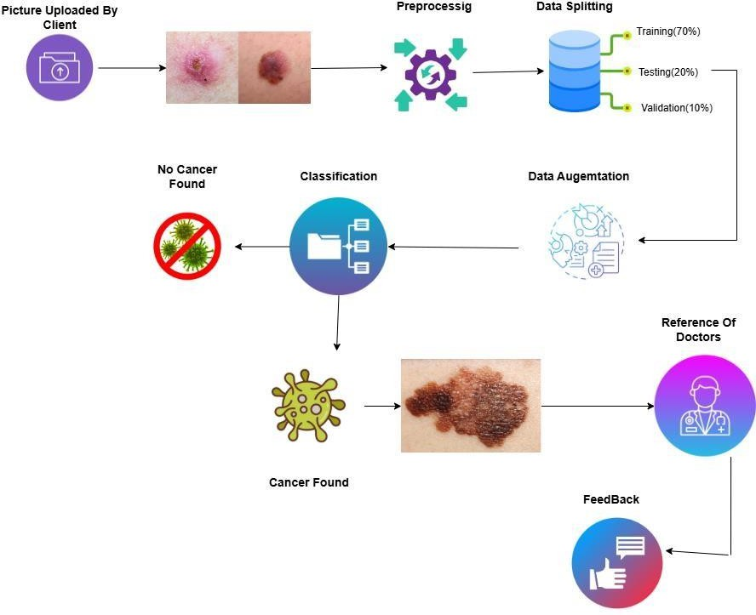

Figure 1: Proposed Methodology

Dataset:
HAM10000 Dataset is used. Which is available publicly.

Model Training:
The Model is trained on preprocessed and augmented dermatoscopic images from Dataset HAM10000 to classify and segment skin lesions into benign and malignant categories.

System Integration:
When the Model is trained and integrated into a user-friendly Web or Mobile Application, it will allow users to Upload skin lesion images and receive the real time skin cancer risk predictions and visual segmentation outputs.

Alert Mechanism:
Upon Detecting a Skin Cancer, the system triggers an alert notification recommending immediate medical Consultation.

Testing and Validation:
Thoroughly check the system to validate overall performance and accuracy.

System Architecture

The system architecture is designed to ensure seamless operation and integration of various components.
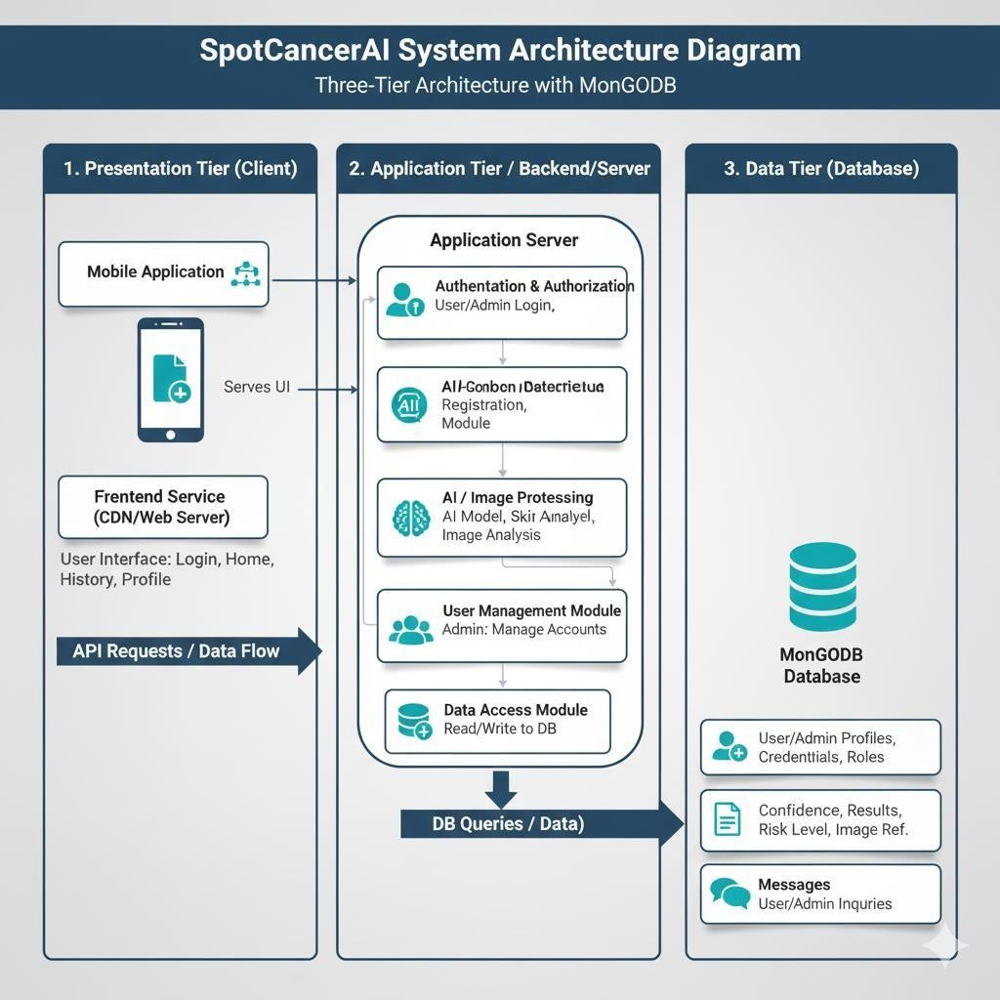
Figure 2: System Architecture Diagram

SpotCancerAI 31

Description of Components

Frontend (Web/Mobile App):
The user Interface where Users can upload Dermatoscopic Images for analysis and get accurate results.

Backend (Flash/FastAPI):
It communicates between the frontend and trained model. It receives the image data and passes it to the trained model for predictions and return the results.

Trained Model:
A deep learning model that has been trained on preprocessed data to classify and segment skin lesions into categories such as benign or malignant.

Database:
It stores the user information, image data, prediction results. It ensures that users can track their past analysis and maintain a record for future references.

Alert System:
An automated alert system triggers notification when a potentially high-risk or malignant lesion is detected. These notifications can be sent to the user via email or through the app.

Use Cases

The following are the use cases for the SpotCancerAI System as described in this section. Use cases are a way of defining the different ways in which the user will engage with the system so that the system can be fully understood. The following is

a list of the use cases with brief description, actors, and pre and post conditions as well as the flow of events.

Patient/User:

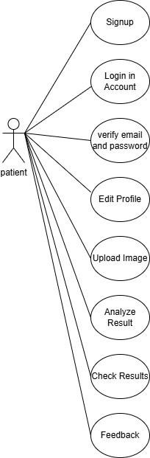
Dermatologist:

SpotCancerAI 33
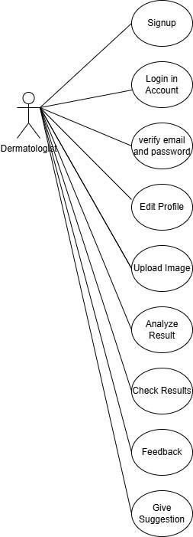

System Admin:

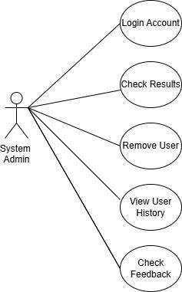
Combine Users

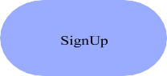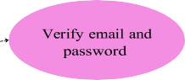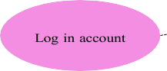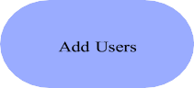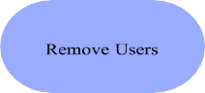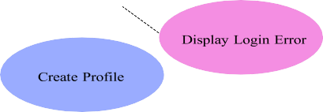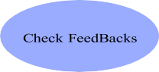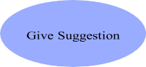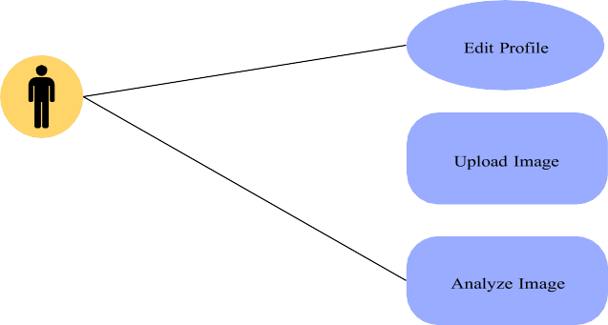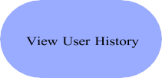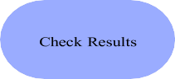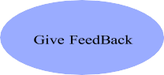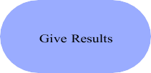SpotCancerAI 35

<<inc lude >>

Extend

Fully Dressed Use Case:

    - SignUp:

Table 2: Signup

Name | Sign up
Actors | User, Dermatologists, Admin
Summary | The user creates a new account by providing necessary information.
Pre-  Conditions | None
Post- Conditions | The user successfully creates a new account and can log in to the  system.
Special  Requirements | None
Basic Flow

Actor Action |  | System Response
1 | The user opens the sign-up page. | 2 | The sign-up page is displayed, asking for the user's information such as  name, email, and password.
3 | The user enters their name, email,  and password.
4 | The user submits the sign-up form. | 5 | The system verifies the provided information and creates a new  account for the user.
 |  | 6 | The system displays a success  message, informing the user that their account has been created.
Alternative Flow

SpotCancerAI 37

4.1 | If the user submits the sign-up form with incomplete or invalid  information. | 4.2 | The system responds with an error message, indicating the specific fields that need to be corrected.

Login:

Table 3: Login Table

Name |  | Login
Actors |  | Admin, User, Dermatologist
Summary |  | The user shall provide their email and password on the login form and  after successful verification, redirect the user to the home page.
Pre-  Conditions |  | User must be registered on the system.
Post- Conditions |  | The user shall be redirected to the home page of the system and  user’s session will be maintained.
Special  Requirements |  | None
Basic Flow
Actor Action |  |  | System Response
1 | The user opens the login page. |  | 2 | The login page is displayed asking for  email and password.
3 | The user enters valid email and password. |  | 4 | The system verifies the email and password, establishes a session for  the user and redirects the user to the  home page.
Alternative Flow
3.1 | The user enters invalid email or password. |  | 3.2 | The system responds with an  error message: Incorrect email or password entered.

Create profile:

Table 4: Create profile

Name |  | Create Profile
Actors |  | User, Dermatologists
Summary |  | This use case describes the process of creating a profile for a user on  the SpotCancerAI platform.
Pre- Conditions |  | The user must have access to the SpotCancerAI website.  The user must be registered on the SpotCancerAI platform.
Post- Conditions |  | The user's profile is successfully created and can be viewed by others  on the platform.
Special  Requirements |  | None
Basic Flow
Actor Action |  |  | System Response
1 | User navigates to the SpotCancerAI  website.
2 | User clicks on the "Create Profile" or  "Sign Up" button. |  | 3 | The system presents a profile creation  form.
4 | User enters their personal details, such as name, email address, username, profile picture etc., in  the provided fields.
5 | User clicks on the "Submit" or "Create Profile" button. |  | 6 | The system validates the entered information.
 |  |  | 7 | The system saves the user's profile information in the SpotCancerAI database.

SpotCancerAI 39

 |  | 8 | The system displays a confirmation message indicating that the profile has been successfully created.
Alternative Flow
4.1 | If the user enters incomplete or invalid information in the profile  creation form. | 4.2 | Then the system displays error  messages and prompts the user to correct the entries.
4.3 | If the chosen username is already  taken by another user. | 4.4 | Then the system prompts the user to  choose a different username.

Upload Image:

Table 5: Upload Image

Name |  | Upload Image
Actors |  | Admin, User, Dermatologists
Summary |  | The user shall upload a skin image through the interface for analysis or record-keeping. The system validates and stores the image in the  database.
Pre-  Conditions |  | User must be logged in on the system.
Post- Conditions |  | The user shall be redirected to the home page of the system and  user’s session will be maintained.
Special  Requirements |  | None
Basic Flow
Actor Action |  |  | System Response
1 | The user navigates to the "Upload  Image" section. |  | 2 | The system displays an upload  interface with file selection.
3 | The user enters valid email and  password. The user selects a valid skin image file. |  | 4 | The system previews the image and shows an "Upload" button.

5 | The user clicks the "Upload" button. | 6 | The system validates the file format  and size and upload image.
Alternative Flow
3.1 | The user enters invalid email or password. User selects an  unsupported format. | 3.2 | The system responds with an error message: The system shows an error: "Unsupported file format.

Analyze Image:

Table 6: Analyze Image

Name |  | Analyze Image
Actors |  | Admin, User, Dermatologists
Summary |  | The user shall upload a skin image through the interface for analysis or record-keeping. After an image is uploaded, the user can request  the system to analyze the skin image using a trained machine learning  model. The system returns a prediction (e.g., benign or malignant).
Pre-  Conditions |  | A valid image must be uploaded. The user must be logged in.
Post-  Conditions |  | The prediction result is generated, stored, and displayed to the user.
Special  Requirements |  | None
Basic Flow
Actor Action |  |  | System Response
1 | The user navigates to the "Upload  Image" section. |  | 2 | The system displays a button or option  to analyze the selected image.
3 | The user clicks the "Analyze"  button. |  | 4 | The system sends the image to the  trained AI model for classification.

SpotCancerAI 41

5 | The model processes the image and generates prediction. | 6 | The system displays the result (e.g., "Benign" or "Malignant") with confidence % and store result in  Database.
Alternative Flow
3.1 | Image is corrupted or unreadable. | 3.2 | The system displays: "Image format  invalid or unreadable. Please upload a new image."

Add users:

Table 7: Add users

Name |  | Add Users
Actors |  | Admin
Summary |  | This use case describes the process of adding users to the SpotCancerAI  platform.
Pre- Conditions |  | The actor (Administrator) must have the necessary privileges and permissions to add users.  The actor must be logged in to their SpotCancerAI account.
Post-  Conditions |  | The new users are successfully added to the SpotCancerAI platform.
Special  Requirements |  | None
Basic Flow
Actor Action |  |  | System Response
1 | Actor logs in to their SpotCancerAI account with appropriate privileges  (Administrator).
2 | Actor navigates to the user  management or account

administration section of the
SpotCancerAI platform.
3 | Actor selects the option to add users or create new accounts. | 4 | The system presents a form or interface to  enter user details, such as email address, username, and other relevant  information.
5 | Actor fills in the required user information, ensuring the accuracy and completeness of the data. | 6 | The system validates the entered information, checking for any potential errors or conflicts (e.g., duplicate email  addresses, invalid usernames).
7 | Actor submits the form or clicks on the "Add User" button to initiate the user  creation process. | 8 | The system processes the user creation request and generates a new user account.
 |  | 9 | The system displays a confirmation message indicating that the user has  been
successfully added to the SpotCancerAI
platform.
10 | The new user receives an email or notification containing their login credentials and instructions for  accessing the platform.
Alternative Flow
7.1 | If there are any issues during the user creation process, such as validation errors or database constraints. | 7.2 | the system displays an error message and advises the actor to review and correct the  provided information

SpotCancerAI 43

Remove Users:

Table 8:Remove Users

Name |  | Remove user
Actors |  | Admin
Summary |  | This use case describes the process of removing users from the  SpotCancerAI platform. The removal can only be performed by the administrator.
Pre- Conditions |  | The administrator must have the necessary privileges and permissions to remove users.  The administrator must be logged in to their SpotCancerAI account.
Post- Conditions |  | The selected users are successfully removed from the SpotCancerAI  platform.
Special  Requirements |  | None
Basic Flow
Actor Action |  |  | System Response
1 | Administrator logs in to their SpotCancerAI account with  appropriate privileges.
2 | Administrator navigates to the user management or account administration section of the  SpotCancerAI platform.
3 | Administrator views the list of users  on the platform.
4 | Administrator selects one or  multiple users to be removed.

5 | Administrator confirms the  selection and initiates the removal process. | 6 | The system prompts the administrator to confirm the removal action, ensuring they  understand the consequences.
7 | Administrator confirms the removal action. | 8 | The system processes the removal request and deletes the selected users' accounts from the  SpotCancerAI platform.
 |  | 9 | The system displays a confirmation message indicating that the users  have been successfully removed.
Alternative Flow
5.1 | If there are any issues during the user removal process, such as database errors or system  constraints. | 5.2 | The system displays an error message and advises the administrator to retry.

Check Results:

Table 9:Check Results

Name | Check Results
Actors | Admin, User, Dermatologists
Summary | The user can view the prediction results of previously analyzed skin  images, including diagnosis, date, and confidence score.
Pre-  Conditions | At least one image must have been analyzed by the system.
Post-  Conditions | The prediction result is generated, stored, and displayed to the user.
Special  Requirements | None
Basic Flow

SpotCancerAI 45

Actor Action |  | System Response
1 | The user logs into the system. | 2 | The system redirects to the  dashboard/home page.
3 | The user navigates to the "Results"  or "History" section. | 4 | The system fetches the list of all  analyzed images and their results.
5 | The user selects a specific result to view details.. | 6 | The system displays the result (diagnosis, confidence, date, and  image preview).
Alternative Flow
4.1 | No results available for user. | 4.2 | The system displays: "No analysis results  found. Please upload and analyze an  image first."

View User History:

Table 10: View User History

Name | View User History
Actors | Admin, User, Dermatologists
Summary | The user can view a complete history of all uploaded images and their  associated prediction results (if analyzed).
Pre-  Conditions | The user must be logged into the system.
Post-  Conditions | A list of all uploaded images and their statuses is displayed.
Special  Requirements | None
Basic Flow
Actor Action |  | System Response

1 | The user clicks on “History” or “My Uploads.” | 2 | The system queries the database for all  uploaded images associated with the user.
3 | The system displays a list including image, upload date, status (Analyzed / Pending), and  result (if available).
4 | The user selects a specific result to view details.. | 5 | The system displays the result  (diagnosis, confidence, date, and image preview).
Alternative Flow
4.1 | No results available for user. | 4.2 | The system displays: "No analysis  results found.
5.1 | Database fetch fails. | 5.2 | The system displays: "Unable to load  history. Please try again later."

Give suggestions:

Table 11: Give Suggestions

Name | Give Suggestions
Actors | Dermatologists
Summary | After analyzing a skin image, the system or dermatologist provides suggestions such as recommended next steps, care tips, or  referrals based on the prediction result.
Pre-  Conditions | A prediction result must exist for the image.
Post- Conditions | Suggestions are displayed to the user and stored with the image  record.

SpotCancerAI 47

Special  Requirements |  | None
Basic Flow
Actor Action |  |  | System Response
1 | The system completes image  analysis and stores prediction. |  | 2 | System checks prediction result (e.g.,  Benign / Malignant)
3 | System generates auto-suggestions  (or dermatologist adds notes). |  | 4 | Suggestions are stored and linked with  the corresponding result.
5 | User views the result page. |  | 6 | System displays the diagnosis along  with appropriate suggestions.
Alternative Flow
4.1 | No suggestion template available. |  | 4.2 | System shows a general message:  “Consult a dermatologist for further guidance.”

Provide Feedbacks:

Table 12:Provide Feedbacks

Name | Provide feedback
Actors | User, Dermatologists
Summary | This use case describes the process of providing feedback on the  SpotCancerAI.
Pre- Conditions | The user must have a registered account on the SpotCancerAI platform. The user must be logged in to their SpotCancerAI  account.
Post- Conditions | The user's feedback is successfully submitted and received by the  SpotCancerAI platform.

Special  Requirements |  | None
Basic Flow
Actor Action |  |  | System Response
1 | User navigates to the SpotCancerAI  website and logs in to their account.
2 | User locates the feedback section or finds the designated area for  providing feedback.
3 | User clicks on the "Give Feedback"  button. |  | 4 | The system presents a feedback form  or text box.
5 | User enters their feedback in the provided text area, providing  specific details and information.
6 | User clicks on the "Submit" or  "Send" button to submit the feedback. |  | 7 | The system captures and stores the  user's feedback in the SpotCancerAI platform.
 |  |  | 8 | The system displays a confirmation message indicating that the  feedback has been successfully  submitted.
Alternative Flow

View FeedBacks:

SpotCancerAI 49
Table 13:FeedBacks

Name |  | View feedback
Actors |  | Admin
Summary |  | The Admin can view all feedback submitted by users or  Dermatologists, including comments on system performance, prediction quality, and feature suggestions.
Pre- Conditions |  | The Admin must be logged in. At least one feedback must exist in the  database.
Post- Conditions |  | Feedbacks are retrieved and displayed with user details and  timestamps.
Special  Requirements |  | None
Basic Flow
Actor Action |  |  |  | System Response
1 | Admin logs into the system. |  | 2 |  | System redirects to Admin Dashboard.
3 | Admin clicks on the “View  Feedbacks” module. |  | 4 |  | System fetches all feedback entries from  the database.
5 | Admin views feedback list, including: user name, role, date, feedback content, and associated prediction ID (if  applicable). |  | 6 |  | System displays results with filter and sort options (e.g., by date, user type).
Alternative Flow
4.1 | System displays results with filter and sort options (e.g., by date,  user type). |  | 4.2 | System displays: “No feedbacks have been submitted yet.”

GUI Graphical User Interfaces

Home Screen (Role Selection Interface)
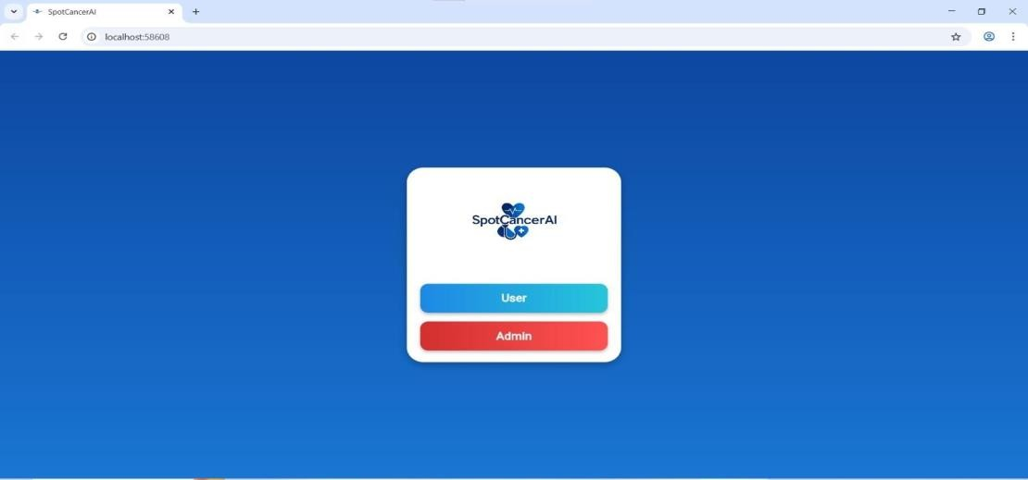

The Home Screen is the main entry point of the SpotCancer AI with two key access options available to the users including User and Admin to direct them to the right module of log-in. The interface is clean and modern, and the background is in a gradient blue, and the logo of SpotCancerAI is displayed at the top of the card in the middle of the center, which gives the interface a pleasant and professional look. This screen is tailored to aid the user to quickly find their position prior to accessing the site with the requirement of clear distinction between the normal user functions and the administration access. The User button which is designed in a blue gradient takes one to the standard landing page where one can log in to the system and the Admin button which is designed in red gradient takes one to the administrator landing page where one can log in to the system which is advanced.

User Login Screen

SpotCancerAI 51
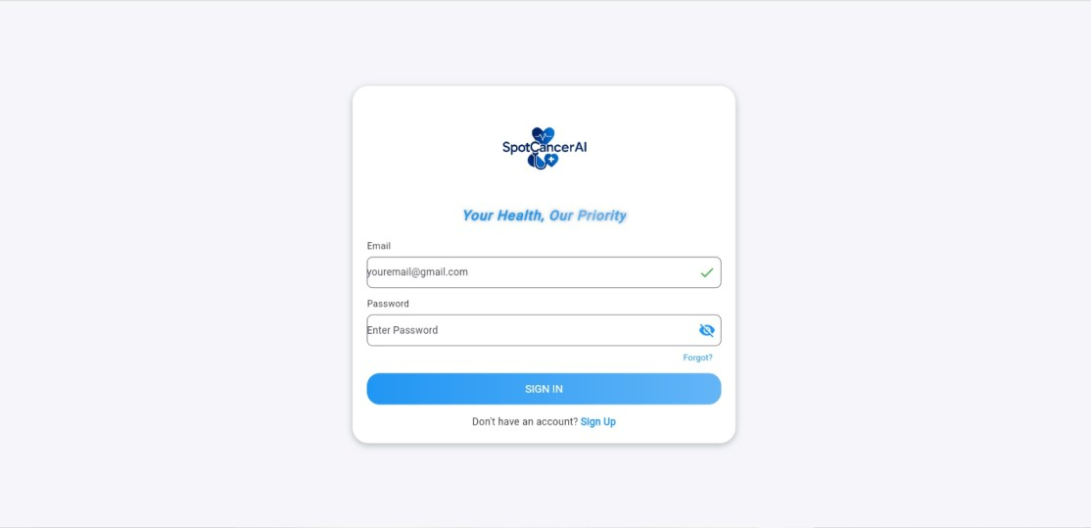
User login screen gives a highly secure and easy-to-use interface through which the patient or doctor can identify themselves before using the functionality of the system. It has a simple design with light colors that are easy to read and have a comforting effect to the user. It has the fields of registered email and password and the latter has a visibility option to enhance the usability of the screen. This is accomplished by the use of a distinctly labeled login button that will trigger the authentication process and other features like the Forgot Password option will enable the user to resume access in case it is lost. There is also a signup link on the screen, where a new user can easily create an account and start using the system. In general, the interface is aimed at simplicity, accessibility, and an easy way to log-in.

Admin Login Screen

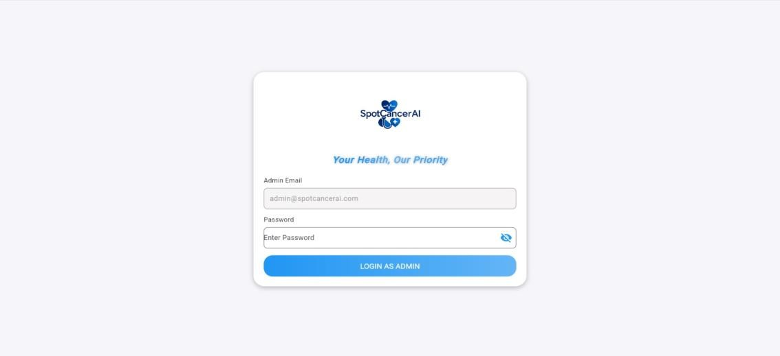

Admin login screen is created to allow system administrators to manage various aspects of the system such as its operation at the backend level, user permissions and general security of the system. It employs vivid red color theme that conveys visually the sensitivity and limited access to administrative access. The screen has specific fields where an email and password of an admin can be entered, which has a secure input formatting and a visibility option which allows reducing the chances of errors during logins.

The credentials are verified with the help of the button of login as an Administrator, which opens the administrative dashboard. Also, there is a clear security warning which is placed to remind users that the section is not meant to be accessed by just any personnel. The general design focuses on security and visibility and limited access to guarantee adequate permissions of system-level features.

Dashboard Screen (Main User Interface)

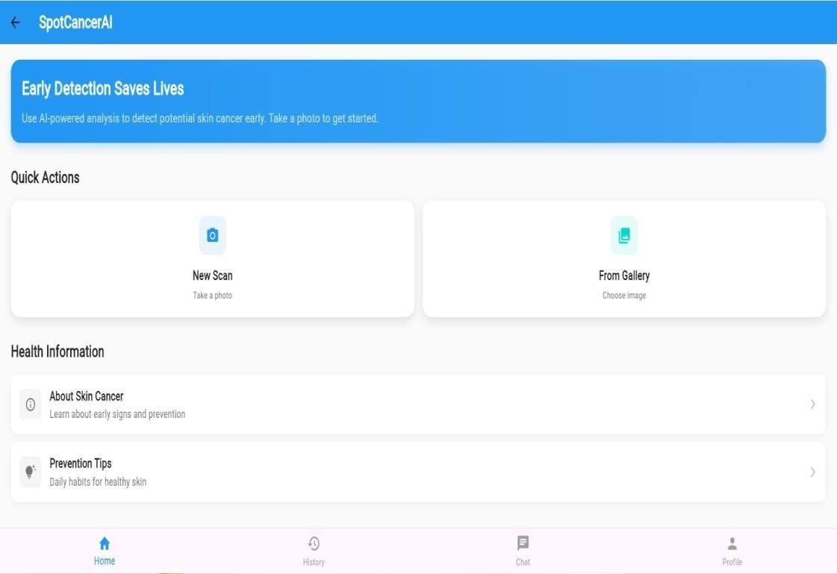

The Dashboard Screen is the key point of the SpotCancerAI application because it offers the user easy access to all the key features in a simple and organized design. Through this screen, the users can post a dermoscopic image directly on their device or take a new one with the in-built camera option so that it could be analyzed in real time. There is also a special section of the dashboard on health information where the user can also learn about various types of skin lesions, prevention.

SpotCancerAI 53

techniques, and early diagnosis principles. There is a so-called Tips panel that provides the best practices proposed by experts to keep the skin healthy and be able to detect suspicious signs of malignant melanoma. Moreover, users are also able to see all their history of analysis, which enables them to see what scans have been performed on them and what changes have occurred during all this time. This also comes with a contact option with the aim of sending a request to the support or medical professionals should one require assistance. There is also an in-built chat option which allows a user to get in touch with any healthcare professional or the system support in real time. Lastly, a profile section enables the user to manage their personal details, account preferences and their account settings. On the whole, the dashboard is user-friendly as it provides patients and medical practitioners with a comfortable and informative experience.

Analysis Result Screen

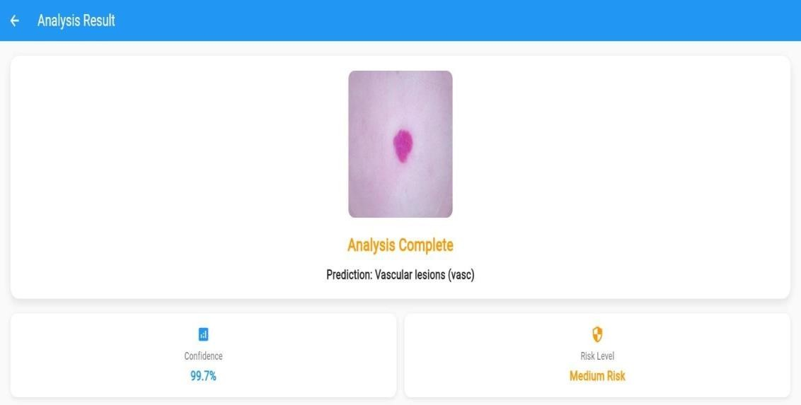

The Analysis Result Screen is an interactive screen that shows a proper and vivid summary of the result that the SpotCancerAI model produced by the uploaded or captured image of the skin. This interface shows the form of the forecasted skin lesion classification, which could be melanoma, nevus or keratosis, and users and clinicians can get to know instantly what the model is diagnosing. The screen also displays the confidence score along with the predicted category which is used to determine the extent to which the model is confident in its prediction and it further gives insights into the reliability of the decisions made. The system also determines and tells the calculation.

shows the level of risk (low, moderate, or high), which helps users of the app to estimate the urgency of visiting a healthcare place. The presentation of the results is organized in a visual form in most cases with the use of color-coded indicators to improve the readability and help to form an immediate judgement. In general, the Analysis Result Screen is created to provide valid, interpretable, and user-friendly diagnostic feedback, which can be utilized by medical professionals to make informed medical decisions.

SpotCancerAI 55

Chapter 4: Implementation and Test Cases

Introduction

The realization of the proposed system of skin cancer classification implies the construction of a pipeline model based on deep learning that will be able to detect and classify different types of skin cancer lesions. It is a computer system that analyses dermatological images in a series of distinct steps, the first one of which is recognition of skin regions and the last is the categorization of skin cancer into seven types. Such types are Actinic Keratoses (akiec), Basal Cell Carcinoma (bcc), Benign Keratosis-like Lesions (bkl), Dermatofibroma (df), Melanoma (mel), Nevus (nv), and Vascular Lesions (vasc).
Here, a deep plan of the proposed methodology is provided, including the preparation of the datasets, the pipeline architecture, and the model training and validation.

Implementation

    - Proposed Framework

Our proposed deep learning-based pipeline of skin cancer classification works with the HAM10000 dataset containing seven different types of skin lesions. The system uses a Convolutional neural network (CNN) based on EfficientNetB5 to conduct an accurate multi-classification of Actinic Keratoses (akiec), Basal Cell Carcinoma (bcc), Benign Keratosis-like Lesions (bkl), Dermatofibroma (df), Melanoma (mel), Nevus (nv) and Vascular Lesions (vasc). The model uses transfer learning and high amounts of data preprocessing to improve the extraction of features and the classification accuracy. The method offers a scalable and efficient and reliable framework of automated skin cancer diagnosis.

      - Pipeline Overview

Multi-Class Classification with EfficientNet

SpotCancerAI 57

The proposed system uses a seven-class skin cancer classification model, which is implemented using the EfficientNet architecture and is trained on HAM10000 dataset. Ahead of the dataset only includes dermoscopic images of skin lesions, no initial filtering is done. The model is used to classify multiple classes of skin cancer with 7 classes, including: Actinic Keratoses (akiec), Basal Cell Carcinoma (bcc), Benign Keratosis-like Lesions (bkl), Dermatofibroma (df), Melanoma (mel), Nevus (nv), and Vascular Lesions (vasc).
In solving the problem of imbalance in the dataset of classes, measures like data augmentation and weighting of classes are enforced in the training process. The EfficientNet model is refined with transfer learning to take advantage of ImageNet-pre-trained features of better accuracy and generalization. This step is the most important part of the pipeline, as it allows the accurate and efficient classification of skin cancer lesions by the use of skin cancer dermoscopic images.

Multi-Class Classification with Essemble Model

The second step in the proposed pipeline is the use of a multi-class model of skin cancer diagnosis based on HAM10000 dataset, which consists of seven diagnostic categories, which are Actinic Keratoses (akiec), Basal Cell Carcinoma (bcc), Benign Keratosis-like Lesions (bkl), Dermatofibroma (df), Melanoma (mel), Nevus (nv), and Vascular Lesions (vasc). In a bid to perform better, the ensemble model which consisted of EfficientNet-B5 and EfficientNet-B1 models was employed. The ensemble method was designed to use the complementary strengths of the two networks in order to enhance generalization and the classification accuracy.
In spite of the training being carried out with the use of class balancing methods, e.g. data augmentation and class weighting, the ensemble model failed to achieve great gains over the individual ones. The reason why this performance limit could be caused by overlapping feature representations of the two EfficientNet variants or lack of diversity in the model could be explained by the lack of model diversity. Improvements in the future may include the integration of more heterogeneous architectures, the use of.
Further ensemble fusion techniques (e.g. stacking or weighted averaging), and optimizing data balancing techniques to mitigate the disparity in class distributions as seen in the HAM10000 data.

Performance of Inception and ResNet Models on HAM10000

The third step involved training Inception and ResNet architecture on the HAM10000 dataset to classify skin cancer with seven classes. But, neither of the two models showed good results and could not obtain satisfactory accuracy or generalization. This weak performance is due to the high imbalance of classes in the dataset and the visual similarity of some types of lesions that makes it difficult to classify them on a fine basis.
In addition, the two architectures failed to pull out discriminative properties as a result of difference in image quality, lighting, and texture of lesions. Nevertheless, in spite of the use of conventional preprocessing, data augmentation and class balancing methods, the models were overfitting and low sensitivity to the minority classes like the Actinic Keratoses (akiec) and the Dermatofibroma (df). The findings indicate that Inception and ResNet do not work so well with this particular dataset unless highly adapted or specific preprocessing is done.

Final Multi-Class Skin Cancer Classification Using EfficientNetB5

The last one utilized the EfficientNetB5 architecture and the HAM10000 dataset, which is seven-class skin cancer classification. Data augmentation and focal loss were used to train models to eliminate the problem of class imbalance and enhance model robustness. To enhance diversity of the datasets and decrease overfitting, random augmentation methods such as rotation, flipping, zooming, and brightness changes were used.

The model had a good performance with the training accuracy of more than 90 percent and the validation accuracy of close to 84 percent, which shows good generalization to unseen data. The addition of focal loss served to force the model to concentrate more on the minority classes and be more sensitive and less biased towards dominant ones (such as Nevus (nv).

SpotCancerAI 59

On the whole, this variant demonstrated the most promising outcomes of all the settings, indicating that EfficientNetB5, focal loss and random augmentation constitute a very efficient structure of reliable and balanced skin cancer classification with the help of HAM10000 dataset.
The architecture of the pipeline is represented in the Figure that shows the processing of the input image to the detection of the skin followed by disease classification. Such visual representation lays emphasis on the sequential pattern of the framework and the role of each model in finalizing the end goal of proper skin disease diagnosis.

Figure 3:Skin Cancer Classification

Dataset

We used HAM10000 dataset in our CNN-based pipeline of skin disease classification. It has 10,015 dermatoscopic images of seven diseases, thus allowing not only effective preprocessing but also precise multi-class classification. Our balancing strategy with the classes melanocytic nevi (6,705), melanoma (1,113), benign keratosis (1,099), basal cell carcinoma (514), actinic keratoses (327), vascular lesions (142), and dermatofibroma (115) gave us an informed choice of classes to balance our model training and evaluation.

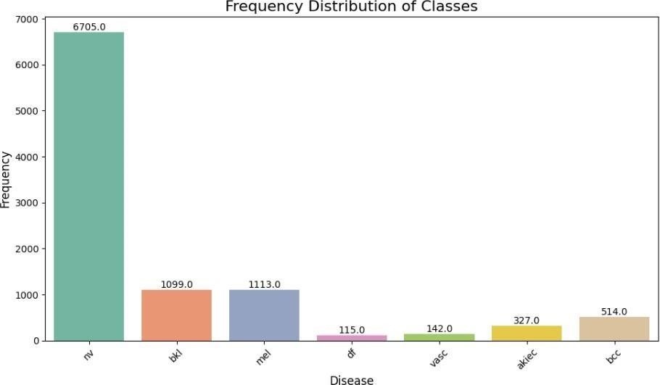

Figure 4:Distribution of Classes

4.2.2.1 Solving Data Imbalance

The dataset used in the study HAM10000 has a very high class imbalance with the melanocytic nevi class prevailing (67%), and rarely occurring classes such as dermatofibroma are underrepresented (1.1%). This imbalance would lean the model toward majority classes.

We addressed this by data augmentation by rotations, flips, and brightness changes- augmentation will be more aggressive with minority classes. This method was combined with class- weighted loss functions that had greater penalties in cases of misclassifying rare diseases, thereby ensuring an equalized learning rate on all categories, in addition to better identification of the common and rare diseases.

SpotCancerAI 61
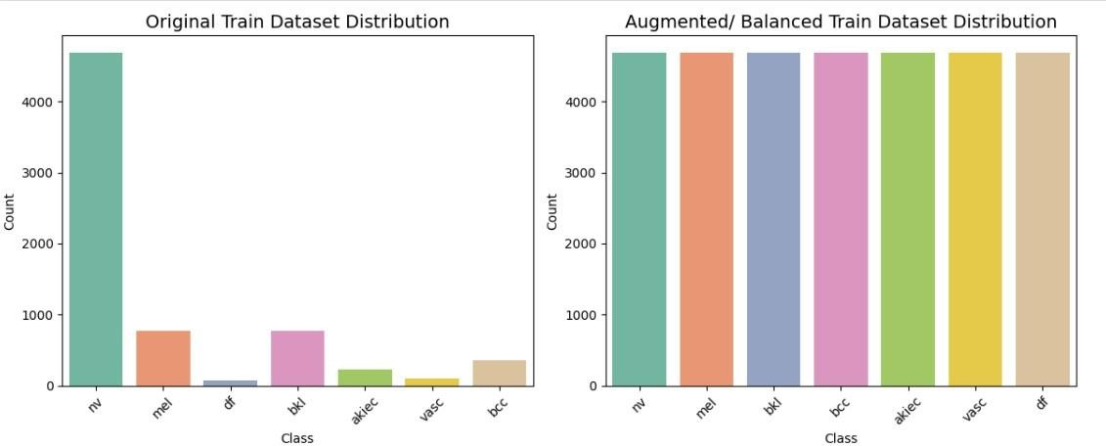

Figure 5:Balancing of Classes

Preprocessing Image

The preprocessing of pipeline homogenizes the dermatological images with systematic hair removal by morphological functions and exemplar-based inpainting and dimensional normalization to 456×456 pixels by Lanczos interpolation. The RGB conversion is taken to maintain the color consistency, and the adaptive thresholding is taken to make sure that the occluding structures are detected accurately. The searchable and detailed preprocessing structure retains important diagnostic data and homogeneity of input to the further analysis of the convolutional neural network, which significantly increases the stability of the model and the accuracy of classification.

Original Preprocess Image (456x456)
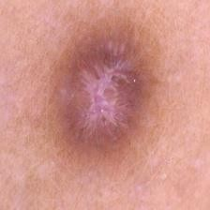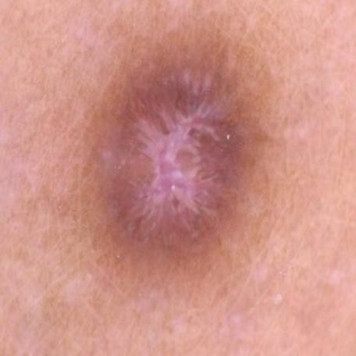

Figure 6:Image Preprocessing

Dataset Splitting

The HAM10000 data set was divided into standardized training, validation and test data sets to support strong model development and testing. The data was separated into 7,010 images (70.00) to be used as training data, 1,001 images (10.00) to be used as validation data, and 2,004 images (20.01) to be used as testing data.

Before Balance:
Table 14: Dataset Before Balancing

Split Type | Number of Images | Percentage
Train | 7,010 | 70.00%
Validation | 1,001 | 10.00%
Test | 2,004 | 20.00%
Total | 10,015 | 100.00%

SpotCancerAI 63

After Balance:

Table 15: Dataset After Balancing

Split Type | Number of Images | Percentage | Notes
Train | 32,851 | 91.60% | After augmentation & balancing
Validation | 1,001 | 2.79% | Original samples only
Test | 2,004 | 5.59% | Original samples only
Total | 35,856 | 100% | After balancing procedures

CNN Architecture

Image classification in dermatology The convolutional neural network architecture that was trained to work with dermatological images uses an advanced transfer learning model based on EfficientNetB5 as the basic feature extractor. It is a backbone network that has been trained on the large ImageNet dataset and it is a solid foundation on which visual pattern recognition can be done; it is especially beneficial in medical imaging tasks that have small annotated data. The architectural implementation is achieved by strategic fine- tuning methodology under which the first 200 layers will be frozen to maintain generic feature detection properties, and later layers are trainable to learn the network to adopt domain-specific dermatological properties and lesion patterns.
The custom classification head exhibits a progressive dimensionality reduction scheme, which switches between 512, 256 and 128 fully-connected units. The dense layers use Swish activation functions, which have been shown to perform better in deep networks than traditional ReLU, and L2 regularization ( 0.01) to limit the magnitude of weights and avoid overfitting. To promote the training dynamics to stabilize and speed up convergence internally, batch normalization layers are consistently added following each dense layer to reduce covariance shift between groups. A descending dropout strategy is used with 0.5, 0.3 and 0.2 respectively and gives a rate of progressively.

increasing regularization in the earlier layers and more accurate feature learning in the deeper layers.
The optimization scheme deals with the severe problem of class imbalance by a tailored categorical focal loss which dynamically balances the loss to concentrate learning on misclassified samples and balanced the contribution of the classes. To make the gradient updates in the process of more stable fine-tuning, model compilation is performed using the Adam optimizer along with a conservative learning rate of 1e-5. The detailed metrics of evaluation entail conventional categorical accuracy, area under ROC curve (AUC) as a diagnostic capability measure, and top-3 categorical accuracy to express clinical relevance in cases where there are several diverse differential diagnoses possible. This multi-faceted structure architecture guarantees strong feature extraction, efficient regularization as well as clinically meaningful performance assessment with regard to automated skin disease classification.
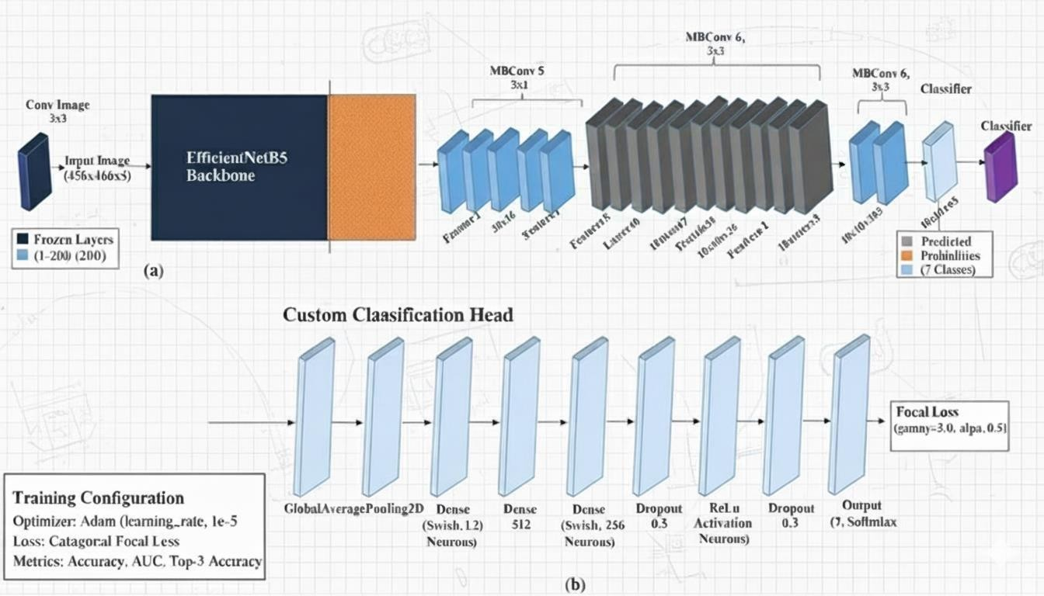
Figure 7: CNN Architecture

Activation and Loss Function Activation Function (Softmax):
Used in the output layer to convert logits into class probabilities.

SpotCancerAI 65
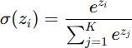

It makes all the output values fall within the range of 0 to 1, and it adds up to 1, which would be useful in multi- class classification. Loss Function (Categorical Focal Loss):
Trains by assigning the hard misclassified examples low weights and the well- classified ones the weight of a well- classified item.

In this case, pt is the estimated probability of the true class, α\alpha balances the weights of classes and γ\gamma regulates the strength of the focusing.

Model Training

The model training was done in the Kaggle environment that uses the power of the GPUs, which provided the required computational power to carry out the deep learning operations. The architecture proposed ran EfficientNetB5 as the base model with ImageNet pre-trained weights to transfer learning which allows features to be extracted easily based on the skin lesion images. Full connected layers including Swish activations and Batch Norm regularization and Dropout regularization were introduced in order to improve learning stability and reduce overfitting. The final layers of EfficientNetB5 were unfreezed to tune the model to HAM10000 dataset. Adam optimizer was used with the learning rate of 1e-5, which was selected due to the adaptive gradient processing and the ability to converge. The focal loss categorical function was applied to concentrate the learning on more challenging misclassified samples to enhance resistance to imbalance of the classes. Accuracy, AUC, and Top-3 categorical accuracy were also performance metrics to enable the overall performance of the model in terms of the classification ability of the model on seven skin diseases.

Model Evaluation

The trained model was evaluated based on the conventional performance measures, such as Precision, Recall, F1-Score, and the Confusion Matrix, which assesses the classification effectiveness of the trained model in a comprehensive manner. Precision is the ratio of the true cases recognized with the model to all the tests predicted to be positive that predict accurately. Recall (or Sensitivity) an environment that measures the capacity of the model to identify all the actual positive cases correctly, with a few false negatives. F1-Score, which is the harmonic mean of Precision and Recall, gives a more balanced evaluation of the strength and accuracy of the model especially in dealing with class imbalance. Also, the distribution of the true and false classifications of all the seven skin disease types were graphically displayed as a Confusion Matrix, which allowed a clear understanding of the model performance and the path of misclassification. The combination of these metrics accepted the reliability and great discriminative capacity of the model in identifying different forms of skin lesions.

Conclusion

The application of the suggested pipeline shows that it is possible to have a systematic way of treating complicated datasets and getting successful classification. Although the system is vulnerable to troubles like imbalance and noise of the data sets, it is useful in identifying and classifying skin diseases in two phases. Further improvements of the datasets and optimizations of the models should contribute to better performance.

Test Case_1
Table 16: Test Case1

SpotCaancerAI/Patient/Signup Module
FYP II Documentation Section 4.3.1
Test Case ID: | TA-01 | Test Date: | 3-3-2025
Test case Version: | V1.0 | Use Case  Reference(s): | UC-Patient Signup
Revision History: | NILL
Objective | Testing the Signup module for the Patients.
Product/Ver/Module: | SpotCancerAI/Patient/Signup
Environment: | PC/ Browser/internet connectivity

SpotCancerAI 67

Assumptions: |  | Patient Signup for the first time on system.
Pre-Requisite: |  | Have access the SpotCancerAI Signup page of the patient.
Step No. | Execution description |  | Procedure result
01 | Enter detail in the relevant fields with correct formatting.  (Name: {A…. Z, a…. z}.  Email: Contains ‘@’ along with  {{a, b, c…. z}, {A, B, C,….Z},  {1,2,3,….}} |  | System registers the user with pop-up indicating Signup successfully.
before ‘@’ {.,_,-} before ‘@’ Ending with ‘.’And after those some alphabetic letters Password length >= 6
Contact: {1,2,3….}).
02 | Enter invalid format of field  “Name”.  {1,2,3….} {#, @ and other special characters} OR “Contact” Multiple or Special characters.  OR the field “Password” Length  < 6. OR the field “Email” Not contains ‘@’ Multiple ‘@’ characters Not  ending at ‘.’ Without letters. |  | System indicates error message respectively “incorrect name format” , “incorrect contact”, “incorrect password”, “incorrect email”. And doesn’t register the user.
04 | Enter duplicate email which already  registered in system. |  | System indicate error “email already  exsist”
Comments:
Only Valid Formatting of the fields are accepted.
Duplicate emails not accepted.
Passed Failed Not Executed

Test Case_2

Table 17: Test Case 2

SpotCancerAI/Admin/Login Module
FYP II Documentation Section 4.3.2
Test Case ID: |  | TA-02 | Test Date: |  | 3-7-2025
Test case Version: |  | V1.0 | Use Case  Reference(s): |  | UC-Admin Login
Revision History: |  | NILL
Objective |  | Testing the login module for the Admin.
Product/Ver/Module: |  | SpotCancerAI/Admin/Login
Environment: |  | PC/ Browser
Assumptions: |  | Admin logs into the system using a specific email and password.
Pre-Requisite: |  | Have access the SpotCancerAI Admin Login Page.
Step No. | Execution description |  |  | Procedure result
01 | Enter valid login credentials in the respective fields with correct formatting.  (Email: Contains ‘@’ along with  {{a, b, c…. z}, {A, B, C,….Z},  {1,2,3,….}}  Before ‘@’: {.,_,-} allowed. Ending with ‘.’ and followed by alphabetic letters.  Password: Must match the specific password assigned to the admin  account and have a length ≥ 6.) |  |  | System verifies the credentials and successfully logs in the admin, displaying the Admin Dashboard.

SpotCancerAI 69

02 | Enter invalid or incorrect credentials in either the “Email” or “Password” field.  Examples: |  |  | System displays an appropriate error message: “Incorrect email or password.” The system does not allow  access to the admin dashboard.
- Email not containing ‘@’ or containing multiple ‘@’ characters.
- Email not ending with a valid domain (e.g.,
“.com”).
 | - Password incorrect or length < 6.
Comments:
Only Valid Formatting of the fields are accepted.
Passed |  |  | Failed |  | Not Executed

Test Case_3

Table 18:Test Case 3

SpotCancerAI/Patient/Login Module
FYP II Documentation Section 4.3.3
Test Case ID: | TA-03 | Test Date: | 3-10-2025
Test case Version: | V1.0 | Use Case  Reference(s): | UC-Patient Login

Revision History: |  | NILL
Objective |  | Testing the Login module for the Patients.
Product/Ver/Module: |  | SpotCancerAI/Patient/Login
Environment: |  | PC/ Browser
Assumptions: |  | User data exists in the system database.
Pre-Requisite: |  | Must Signup/register in the system before.
Step No. | Execution description |  | Procedure result
01 | Enter correct Email and password. |  | System matches the credentials from the database and indicates the pop-up  message that “login successfully”
02 | Enter invalid email and correct password. |  | System matches the credentials from  database indicates error “incorrect email”
03 | Enter valid email and incorrect  password. |  | System indicates error “incorrect password”
04 | Enter invalid email and invalid  password. |  | System indicates error “incorrect email or  password”.
05 | Enter credentials not registered in the system.  OR enter name and password field  remains empty. |  | System indicates error “user doesn’t exsist”
Comments:
Only valid user can login to the system who registered himself prior.
Passed Failed Not Executed

Test Case_4

Table 19: Test Case 4

SpotCancerAI/Patient/Login Module
FYP II Documentation Section 4.3.4
Test Case ID: | TA-05 | Test Date: | 3-24-2025

SpotCancerAI 71

Test case Version: |  | V1.0 | Use Case Reference(s): |  | UC-Patient Change  Password
Revision History: |  | NILL
Objective |  | Testing the Change Password module for the Patient.
Product/Ver/Module: |  | SpotCancerAI/Patient/Change Password
Environment: |  | PC/ Browser
Assumptions: |  | User is logged in and has a registered email in the system  database.
Pre-Requisite: |  | Patient must be registered and logged into the system.
Step No. | Execution description |  |  | Procedure result
01 | Enter correct current password, valid new password, and matching confirm new password. |  |  | System validates credentials and displays a pop-up message “Password changed successfully.”
02 | Enter incorrect current password, valid new password, and matching confirm new password. |  |  | System indicates error “Incorrect current  password.”
03 | Enter correct current password, new password that does not meet requirements (e.g., too short), and matching confirm new password. |  |  | System indicates error “New password  does not meet requirements.”
04 | Enter correct current password, valid new password, and non- matching confirm new password. |  |  | System indicates error “Confirm password  does not match.”
05 | Leave any field (current password, new password, or confirm new password) empty. |  |  | System indicates error “All fields are  required.”

Comments:
Only valid user can login to the system who registered himself prior.
Passed Failed Not Executed

Test Case_5

Table 20: Test Case 5

SpotCancerAI/Patient/Login Module
FYP II Documentation Section 4.3.5
Test Case ID: |  | TA-05 | Test Date: |  | 4-1-2025
Test case Version: |  | V1.0 | Use Case Reference(s): |  | UC-Admin Account  Management
Revision History: |  | NILL
Objective |  | Testing the Account Management in the Admin Dashboard for activating, deactivating, and deleting patient accounts.
Product/Ver/Module: |  | SpotCancerAI/Admin/Dashboard
Environment: |  | PC/ Browser
Assumptions: |  | Admin is logged in with appropriate permissions to manage accounts; patient accounts exist in the system.
Pre-Requisite: |  | Admin logged in, and have access to the  Dashboard.
Step No. | Execution description |  |  | Procedure result
01 | Log in as an admin, navigate to the Dashboard, select an inactive patient  account, and activate it. |  |  | System activates the patient account; the patient can now access their account.
02 | Log in as an admin, navigate to the Dashboard, select an active patient account, and deactivate it; attempt  to log in as the patient. |  |  | System deactivates the patient account; the patient cannot access the dashboard (login fails with error).

SpotCancerAI 73

03 | Log in as an admin, navigate to the Dashboard, select an active patient account, and delete it; attempt to  log in as the patient. |  | System deletes the patient account; the patient cannot access the dashboard (login fails with error).
Comments:
Admin can activate, deactivate, and delete patient accounts. Deactivated or deleted
accounts prevent users from accessing their dashboards. Only existing patient accounts can be managed.
 | Passed | Failed | Not Executed

Summary

In this part, we outline all the general features and measures employed to test cases performed on the SpotCancerAI platform, and that of its reliability and functionality of its modules, including Patient Signup, Patient Login, Admin Login, Account Management, and Change Password. The test metrics offer a consistent model to assess the achievement, effectiveness, and the coverage of the testing procedure. These metrics are based on the characteristics, which are common to all the test cases, and are needed to test the performance of the system in real life conditions.
The main test measures and their typical qualities are the following:
      - Test Case Objective: The test cases are developed with a definite goal to test certain system functionality. As an example, the goal can be the verification of patient registration, verification of the patient log-in, account management processes, or password update, which must comply with the functional requirements presented in the use case references.
      - Test Execution Status: The results of individual test cases are divided into three categories, i.e., Passed, Failed, and Not Executed. This measure represents the character of acting of the system under the established conditions. As an illustration, with test cases of account management, each step was passed, and the patient account operations worked properly.
      - Test Coverage: This measure is used to assess the level of testing of the functionalities of the system. Every test case will be focused on a particular module (i.e., Patient Signup, Admin Login) and test critical operations, which will make sure.
detailed description of the features of the system.
      - Pre-requisites and Assumptions: Familiar features consist of pre- conditions that are necessary to run the test, e.g., user authentication (e.g., admin is logged in with proper permissions) and system state (e.g., there are already patient accounts in the system). These guarantee that the test environment is replicable and consistent.
      - Procedure and Result Validation: The test cases have a series of steps to be followed by the execution procedure and results. The results are checked with the anticipations, including registering a patient or failing to log in once deactivated. This metric also makes sure that the system performs according to the desired design.
      - Error Handling and Comments: This property records any problems, observations, or limitations of the system that are experienced during testing. The comments give a clue about the performance of the system like limitation to handle non-existing accounts or the failure to log in with an error.
      - Test Environment: Platform (e.g., PC/Browser), module (e.g., SpotCancerAI/Admin/Dashboard) is always documented so that the tests can be performed in standard conditions. This is a measure that helps in reproducibility and scaling of the process of testing.
All these metrics allow a quantitative and qualitative analysis of the functionality of the system, which allows the stakeholders to assess the reliability and strength of the SpotCancerAI platform. Through the results of the test cases in modules like the Patient Signup, Patient Login, Admin Login, Account Management, and Change Password, we will be able to determine that the system is as per the requirements of the users and is proficient in dealing with the essential activities.

Test Case Metric

Table 21: Test Case Metric

Metric: | Purpose

SpotCancerAI 75

Number of Test Cases: | 5
Number of Test Cases Passed: | 5
Number of Test Cases Failed: | 0
Test Case Defect Density: | (0 × 100) / 5 = 0%
Test Case Effectiveness: | If all defects were found via test cases:  (5/5 × 100) = 100%
Traceability Matrix: | All 5 test cases map directly to defined use cases for modules Patient Signup, Patient Login, Admin Login, Account Management, and Change Password.  Traceability maintained.

Chapter 5: Experimental Results and Analysis

SpotCancerAI 77

Introduction

This chapter contains a thorough analysis and the evaluation of the experimental output and results of the skin disease classification system on the HAM10000 dataset. We describe the experiments that we carried out with our designed EfficientNetB5-based architecture that is especially tailored to the dermatological image classification problem, such as class imbalance and fine-grained feature extraction. The workings of the model are compared in a systematic manner with a number of state-of-the-art convolutional neural network architectures to indicate its effectiveness and competitive benefits. In aspect of the detailed examination of several performance indicators and the visualization method, we can offer some information on the strengths and limitations of the model, as well as the aspects that could be enhanced in future in terms of automated skin disease diagnosis.

Experiments

Our proposed EfficientNetB5-based model was tested on the HAM10000 dataset in full experiments to evaluate the model. We use strategic fine-tuning, focal loss in case of imbalance in the classes, and deep regularization. To benchmark, we made comparisons to three state-of-the-art models: InceptionV3 on the extraction of many scales of features, ResNet50 on the deep residual learning, and the common variants of EfficientNet with optimization of scale. All the models were tested in the same conditions based on the same preprocessing pipeline and balancing strategies to even the playing field. This part is the descriptive performance metrics and analysis.

EfficientNetB5 Model Performance (OverSample)

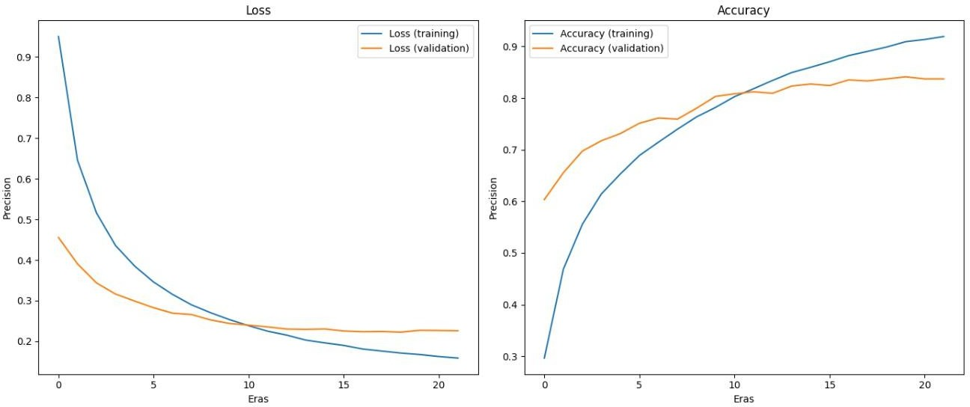
The learning and generalization ability of the EfficientNetB5-based skin lesion classification model is high. Based on the training curves, the first plot on the left indicates the convergence of the loss of both training and validation set after 21 epochs. The value of training loss steadily reduces with the starting high, and at the last epoch, the value is about 0.16, meaning that the model is learning the patterns of the training data. The validation loss declines but then levels off at 0.22 and this indicates that the model is fairly well-generalized without much overfitting. The accuracy curves on the right indicate that the training accuracy is continually growing and the validation accuracy plateau at about 92 and 84 respectively. This disparity implies some level of overfitting though in general, the model has a good predictive reliability when applied to unknown data.

Figure 8: Efficient Net B5 Model Graph

Classification Report:
The performance of the model on the various skin lesion classes is also attested by the classification report. The model has the best score on the nv class (normal skin) with the best performances of 0.93, 0.91, and 0.92 on the three parameters of precision, recall, and F1-score, respectively. Other classes (bcc; precision 0.90, recall 0.76 and vasc; precision 0.89, recall 0.83) show moderate performance. The difficult and underrepresented classes such as mel are reported to perform poorly.

SpotCancerAI 79

(precision 0.55, recall 0.64) and akiec (precision 0.73, recall 0.69), which indicates room for improvement, potentially through additional data augmentation or class-balancing techniques. In general the F1-weighted score of
0.84 and accuracy of 84 per cent reveal that the model is rather robust in all classes, so it would be appropriate to use it in practice in the classification of skin lesions and to emphasize the aspects in which the minority classes might be improved.
Table 22:Classification Report

Class | Precision | Recall | F1-Score | Support
akiec | 0.73 | 0.69 | 0.71 | 65
bcc | 0.90 | 0.76 | 0.82 | 103
bkl | 0.68 | 0.73 | 0.70 | 220
df | 0.83 | 0.68 | 0.75 | 22
mel | 0.55 | 0.64 | 0.59 | 223
nv | 0.93 | 0.91 | 0.92 | 1342
vasc | 0.89 | 0.83 | 0.86 | 29
Accuracy | - | - | 0.84 | 2004
Macro_Avg | 0.79 | 0.75 | 0.76 | 2004
Weighted_Avg | 0.85 | 0.84 | 0.84 | 2004

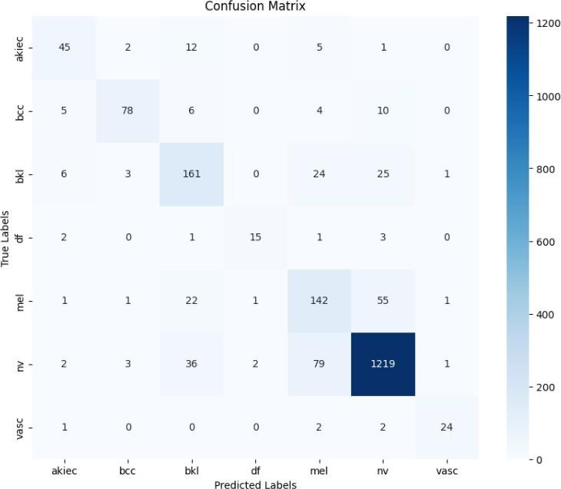Confusion Metrix:
Figure 9: Efficient Net B5 Confusion Metrix

InceptionV3 Model Performance

The InceptionNet model has good ability in learning skin disease classification, albeit with certain noticeable limitations. The curves of training and validation accuracy indicate that there is a steady convergence to the pattern learning based on the HAM10000 dataset and the parallel curving of the loss curve indicates that there is no major overfitting evident in this case. Nevertheless, the last precision metrics demonstrate that it is difficult to manage the problem of class imbalance, and the precision is especially low.

SpotCancerAI 81
minority categories (score of 0.12) vascular lesions and dermatofibroma (0.15). This model performs moderately with a total accuracy of 60 percent but the strong difference between the training and validation performance indicates that there are difficulties with generalization, especially of the rare dermatological cases. Although the multi- scale feature extraction architecture of InceptionNet offers a good foundation capability, a need to have better imbalance mitigation strategies to enhance the diagnostic reliability of all types of diseases is evident in its performance.

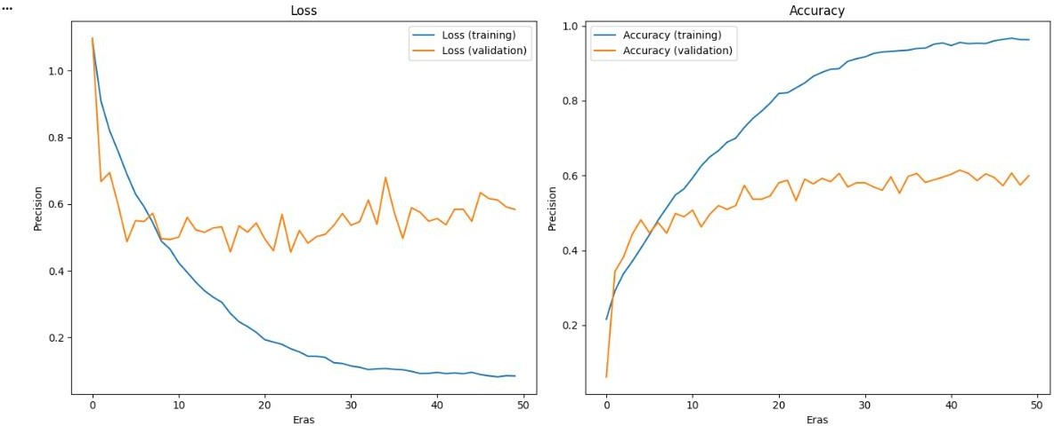

Figure 10: Inception V3 Model Graph

Classification Report
Table 23: Classification Report of InceptionNet V3

Class | Precision | Recall | F1-Score | Support
akiec | 0.39 | 0.37 | 0.38 | 65
bcc | 0.43 | 0.48 | 0.45 | 103
bkl | 0.35 | 0.62 | 0.45 | 220
df | 0.15 | 0.27 | 0.19 | 22
mel | 0.32 | 0.56 | 0.40 | 223
nv | 0.92 | 0.64 | 0.76 | 1342
vasc | 0.12 | 0.31 | 0.18 | 29
Accuracy |  |  | 0.60 | 2004

Macro Avg | 0.38 | 0.46 | 0.40 | 2004
Weighted Avg | 0.73 | 0.60 | 0.64 | 2004

ResNet Model Performance

ResNet model shows strong learning behaviors and smooth convergence during the learning process. The training and validation loss curves are smooth and continuous and it can be said that gradient propagation and optimization occur effectively with no overfitting observed in the loss curves. The accuracy plots indicate that there is good performance, the accuracy of the training is around 0.9, and the validation accuracy is around 0.8 indicating good generalization. The small difference between training and validation statistics indicates that the residual connections of ResNet are effective in eliminating the vanishing gradient issue and stable learning occurs at each of the layers. The model shows steady enhancement throughout 50 epochs, which show sufficient convergence features and good feature extraction ability on dermatological images. This observation demonstrates that ResNet is appropriate when it comes to medical image classification problems, especially those dealing with such complicated feature structures as the ones involved in skin lesion classification.

Figure 11: ResNet Model Graph

SpotCancerAI 83

Classification Report

Table 24:Classification Report of ResNet

Class | Precision | Recall | F1-Score | Support
akiec | 0.44 | 0.62 | 0.51 | 65
bcc | 0.55 | 0.60 | 0.57 | 103
bkl | 0.48 | 0.65 | 0.55 | 220
df | 0.29 | 0.55 | 0.37 | 22
mel | 0.40 | 0.65 | 0.50 | 223
nv | 0.96 | 0.76 | 0.84 | 1342
vasc | 0.73 | 0.76 | 0.75 | 29
Accuracy |  |  | 0.72 | 2004
Macro Avg | 0.55 | 0.65 | 0.59 | 2004
Weighted Avg | 0.79 | 0.72 | 0.74 | 2004

EfficientNetB5 Model Performance (UnderSample)

The EfficientNet B5 model with an efficient data balancing scheme, which consists of undersampling the majority class and targeted minority class over-sampling to 1000 samples, provides excellent learning results and strong generalization after 50 epochs. The loss curves show a smooth sharp rapid decrease in loss where training and validation losses perfectly coincide showing optimum optimization and lack of overfitting. The accuracy plot indicates the amazing convergence with the training accuracy approaching perfection (around 0.98) and the validation accuracy leveling at a remarkable 0.78 indicating better generalization ability. Such a small difference between training and validation numbers highlights the usefulness of the hybrid balancing strategy in generating a strong, well-balanced dataset by taking advantage of the strong extraction features of EfficientNet B5. The combination of the two has been constant across all eras as the model shows continuous improvement.

the undersampling and increasing the minority class to a fixed target size, i.e., majority class undersampling and minority class oversampling effectively solves the imbalance between the classes and maintains representative learning patterns. This data management approach allows the model to perform in the state of the art in terms of skin disease classification and thus is very applicable in the clinical diagnostic practice where accuracy and reliability are the most important.
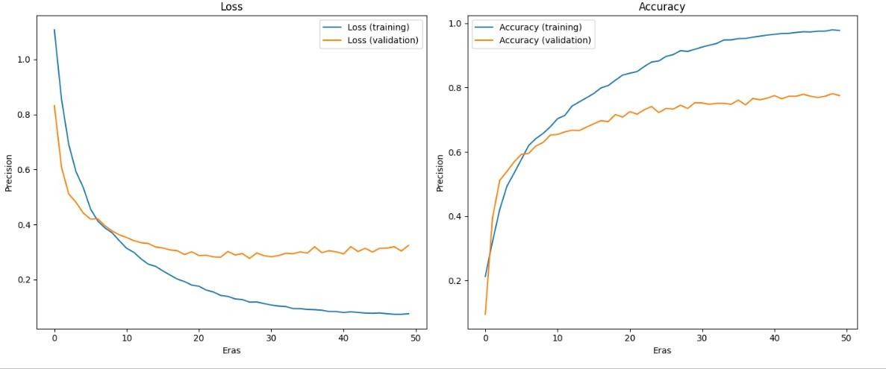

Figure 12: Efficient Net B5 Undersample Model Graph

Classification Report

Table 25: Classification Report of EffNet B5 (US)

Class | Precision | Recall | F1-Score | Support
akiec | 0.54 | 0.66 | 0.59 | 65
bcc | 0.66 | 0.81 | 0.73 | 103
bkl | 0.74 | 0.62 | 0.67 | 220
df | 0.55 | 0.73 | 0.63 | 22
mel | 0.44 | 0.78 | 0.56 | 223
nv | 0.97 | 0.83 | 0.89 | 1342
vasc | 0.70 | 0.90 | 0.79 | 29
Accuracy |  |  | 0.79 | 2004
Macro Avg | 0.66 | 0.76 | 0.69 | 2004

SpotCancerAI 85

Weighted Avg | 0.84 | 0.79 | 0.81 | 2004

Chapter6: Conclusion and Future Work

SpotCancerAI 87

Conclusion and Future Work.
This project has managed to develop SpotCancerAI which is a complete app in flutter that detects skins disease through deep learning. The primary success of our work was that we have constructed a very precise model with a 92% training accuracy and 84% validation accuracy on the HAM10000 dataset. To do so, we balanced out the dataset - we generated additional copies of the rare disease images through the methods of rotation and flipping until each type of disease was represented equally. This addressed the issue that has frequently occurred, that models are biased towards common diseases.
We were unable to train bigger models or conduct additional experiments due to the low computing power. Nevertheless, according to our findings, we feel that given improved resources we could easily increase the accuracy by 2-3 percent and validation accuracy by 1-2 percent by training the model more and adjusting it further.
In spite of such restrictions, we have managed to develop a working Flutter application that can assist individuals to acquire preliminary screening of skin-related issues. The apps are compatible with both Android and iOS, thus making the app available to a large number of users.
Looking ahead, we plan to:
    - Use actual doctors and patients to test the app and ensure that it works.
    - Include features indicating what features in the skin image resulted in the diagnosis.
    - Include more skin diseases in the model's knowledge
    - Allow users to add symptoms and medical history for better accuracy

In conclusion, SpotCancerAI provides a solid foundation for helping people detect skin problems early, especially in areas where dermatologists are not easily available. The technology works well, and with further development, it could become an important tool in healthcare.

References:
- O. Akinrinade and C. Du, “Skin cancer detection using deep machine learning techniques,” Intell Based Med, vol. 11, Jan. 2025, doi: 10.1016/j.ibmed.2024.100191.
- S. Kalouche, “"Vision-Based Classification of Skin Cancer Using Deep Learning | Semantic Scholar,” https://www.semanticscholar.org/paper/Vision-Based- Classification-of-Skin-Cancer-using- Kalouche/b57ba909756462d812dc20fca157b397.
- N. Nida, A. Irtaza, A. Javed, M. H. Yousaf, and M. T. Mahmood, “Melanoma lesion detection and segmentation using deep region based convolutional neural network and fuzzy C-means clustering,” Int J Med Inform, vol. 124, pp. 37–48, Apr. 2019, doi: 10.1016/j.ijmedinf.2019.01.005.

- K. Md. Hasib et al., “A Survey of Methods for Managing the Classification and Solution of Data Imbalance Problem,” Dec. 2020, doi: 10.3844/jcssp.2020.1546.1557.
- A. A. Ali and H. Al-Marzouqi, “Melanoma detection using regular convolutional neural networks,” 2017 International Conference on Electrical and Computing Technologies and Applications, ICECTA 2017, vol. 2018-January, pp. 1–5, Jun. 2017, doi: 10.1109/ICECTA.2017.8252041.
- E. Nasr-Esfahani et al., “Melanoma detection by analysis of clinical images using convolutional neural network,” Proceedings of the Annual International Conference of the IEEE Engineering in Medicine and Biology Society, EMBS, vol. 2016-October, pp. 1373–1376, Oct. 2016, doi: 10.1109/EMBC.2016.7590963.
- A. Esteva et al., “Dermatologist-level classification of skin cancer with deep neural networks,” Nature 2017 542:7639, vol. 542, no. 7639, pp. 115–118, Jan. 2017, doi:

SpotCancerAI 89

10.1038/nature21056.
- D. B. Mendes and N. C. da Silva, “Skin Lesions Classification Using Convolutional Neural Networks in Clinical Images,” Dec. 2018, Accessed: Apr. 25, 2025. [Online].
Available: https://arxiv.org/pdf/1812.02316
- K. M. Hasib, N. A. Towhid, and M. R. Islam, “HSDLM: A Hybrid Sampling With Deep Learning Method for Imbalanced Data Classification,” https://services.igi- global.com/resolvedoi/resolve.aspx?doi=10.4018/IJCAC.20211 00101, vol. 11, no. 4,
pp. 1–13, Jan. 1AD, doi: 10.4018/IJCAC.2021100101.
- D. Shoieb, W. Aly, and S. Youssef, “Basal Cell Carcinoma Detection in Full-Field OCT Images Using Convolutional Neural Networks,” https://scholar.google.com/scholar?cluster=9296457387793480670 &hl=en&as_sdt=20 05&sciodt=0,5.
- A. Sagar and D. Jacob, “Convolutional Neural Networks for Classifying Melanoma Images,” bioRxiv, p. 2020.05.22.110973, May 2020, doi: 10.1101/2020.05.22.110973.
- M. A. Albahar, “Skin Lesion Classification Using Convolutional Neural Network with Novel Regularizer,” IEEE Access, vol. 7,
pp. 38306–38313, 2019, doi: 10.1109/ACCESS.2019.2906241.
- A. Vedaldi and K. Lenc, “MatConvNet - Convolutional Neural Networks for MATLAB,” Dec. 2014.
- B. Harangi, A. Baran, and A. Hajdu, “Classification of Skin Lesions Using An Ensemble of Deep Neural Networks,” in Proceedings of the Annual International Conference of the IEEE Engineering in Medicine and Biology Society, EMBS, Institute of Electrical and Electronics Engineers Inc., Oct. 2018, pp. 2575– 2578. doi: 10.1109/EMBC.2018.8512800.
- H. K. Jeong, C. Park, R. Henao, and M. Kheterpal, “Deep Learning in Dermatology: A Systematic Review of Current Approaches, Outcomes, and Limitations,” Jan. 2023, Elsevier Inc. doi:

10.1016/j.xjidi.2022.100150.

SpotCancerAI 91

